#$ % $ &

– # ( #) ( * # +* ,% –

[*http://www.qeyas.com*](http://www.qeyas.com/)

# êÛÓÖ] ðˆ¢]

5 * 4 !

#) # *3



: (0) - .

|  |  |
| --- | --- |
| ( | ( |
| ( | ( |

: 

! = = =

" #$

! = × ×

× !



= (: 89 ) ( 8 7 ) : (6) - .



|  |  |
| --- | --- |
| )' & - ( | ' & ( |
| )' & ( | ' & ( |

: 

)' & - = (&+ )' × ( - × + )



% ?3 =% ( @ %A # A % B > 6: =% : < - : (:) - .



5 C % (N) . 0EE F $ G* H , IJ) K L% 6E C = D<

|  |  |
| --- | --- |
| ( | - ( |
| ( | & ( |

5 67 ./

:  1 2 3 .4$ ./ ' /0 ./

" #$

& + 1 = '

5 ='

= 5+1+'

= 5 + & – ' + 5

=5+ & -5 +5

&= 5 9 : &=5

9 : & = 67 ./ ;:<=



= × !



: (8) - .

|  |  |
| --- | --- |
| ( | - ( |
| ++ ( | ! ( |

-: 

++ = ( ++ × ) × !



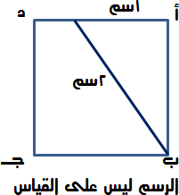5 PQ R A% < (O) - .



|  |
| --- |
| ] ( |
| o ] ( |
| & ( |
| ( |



] = 4 / = =G= H / = J

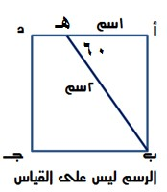

.D D

] = " #$

& = ]

× ]

= K4./ 0 < ;:<=

) K L%! < A = T @%U VW # H L%! < : (S) - .



5 L%! %U VW

|  |  |
| --- | --- |
| L ( | L ( |
| ÷ L ( | ÷ L ( |

: 

N.O 0 < × = P N.O 0 <

L Q × = L Q

L = L V B.W? AU 4.J GRH RST4

L = L

;:<=

P N.O .W XY = N.O .W XY

L = N.O .W XY



= \ 4 G* H , K [E *@ & YZ* H , I : (X) - .

5 ]%&^ _`3 ^ G* ) K ( 6E 9 )



|  |  |
| --- | --- |
| ( | ( |
| ( | & ( |

2 5 /H<

: 

= A4 Z J/

3

( - ' + ' + & ' + ' + ' ) =

-' + ' + &'- + ' + ' = - ×

-' + ' + &' + ( - ) =

-' + ' + &' = +

" #$

= -' + ' + &' = [.S\ !F@ \ 5 /H<



êÞ^éfÖ] Ü‰†Ö]

6EES a A #) b \ B ) c YD $ %d $

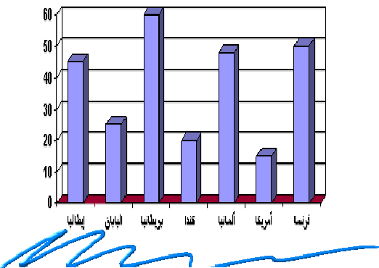

5 ) c $ %c $ #) B 4 = :([) - .



|  |  |
| --- | --- |
| .B= W6.4 ( | W6.4= / ( |
| W6$= / ( | .B= W6$ ( |

: 

.B= W6.4



B e D N H*N Z > f (N) K > f SE YD ? %A % Z H , I : (7) - .

5 $ %c ) d A # U %$ b \



|  |  |
| --- | --- |
| ( | ( |
| + ( | + ( |

: 

% c ; b= H V< `a = A W6.] V_ /? ]6.^ ] ' ;a.g = ( N 6I ) ]6.^ G < f= e

% b UD A?h\ .U

% b UD N 6I '

" #$

% × ' = % ×

× ' = % × & = ÷ ( × ) = ]6.^ G < = '

A?h\ .U j? ;U/H Pi

+ = & + = m?;J / j? kJg?lD



íÞ…^Ï¹] í×ò‰_

5 4 A H K >f 8O B >f :O 4 C ^ 4 ( , 0E % Z D : (0E) - .

|  |  |
| --- | --- |
| @ / | j =\ / |
| % - | N 6I? 6 n/ ] : |

: 



5 gDGf U4 5 gDGf 5 gDGf ]

1 ' %

- &-

" #$

' = N 6I? 6 n/ ] :

% × = &- × '

% + = . + e6. J 4 = . - = '

;:<=

% - < % +



4 A H : (00) - .

|  |  |
| --- | --- |
| @ / | j =\ / |
| ( . +) ÷ - | ( . ) ÷ - |

+ - = + × -

: 

= × - = ÷ - : j =\ /

) + ×

-

= × - = × - = + ÷ - : @ /

) × + +

"#$

j =\ / < @ /



# ê¿Ë×Ö] ðˆ¢]

9 .g/ A U< – b=\ pIH

& : (06) - .



|  |  |
| --- | --- |
| G 0 p :! .r ; = s._ ( | B.U/ V ?D AB qG J ( |
| 2;D ; D AB V6.S\ vG w< ( | X?Jt< u AB N.lB $ ( |

:  G 0 p :! .r ; = s._



. \ c< \A k #) %j$ ( ^ 4 g A h i U : (0:) - .



|  |  |
| --- | --- |
| ;4 k6 :J ( | ; ? x.UJ ( |
| ; B L/UJ ( | ; ? x ( |

: 

; B L/UJ

/H b /v$ – A @ pIH 

. * \ ........ $$ C K lD L Z B ....... R $Z^ 4 :(08) - .



|  |  |
| --- | --- |
| N U]/ – a./ ( | <G Y - ^g/ ( |
| HJ:/ – B T/ | ] H – 6 y/ ( |

: 

] H – 6 y/



L% gW m n ? *U o * p%q 4N K L%_. ........ Z C D : (0O) - .

........ (r 4



|  |  |
| --- | --- |
| kD IH:< – ; B.D ( | kD ]? – <F $ ( |
| kD UJ – O ( | kD /3 < – 6.6 WD ( |

: 

kD ]? – <F $



Arg? .z :J – > @ pIH

(Z : n : (0S) - .



|  |  |
| --- | --- |
| w< : NG ( | b _ : ' ( |
| P H:B : N ; ( | . ]lD : G r:< ( |

: 

. ]lD : G r:< " ? = " FU 5

2 .? ? = w6.

. ]lJ? ? = G r:/



#\+ : + : (0X) - .

|  |  |
| --- | --- |
| D : _ ( | 7 B : = ( |
| .w : 4 ( | NG $ : p 4.;v ( |

: 



D : _

" j $ q J 6 " FU 5 A;W j $ q J 6 UW B

J q J D W =



A : -`@ : (0[) - .

|  |  |
| --- | --- |
| : : 6 ( | : ! ( |
| N JB : ]| ( | ;v : g_ ( |

: 



;v : g_ " ?0.< " FU 5 G 4 j $ b J6 bF;

;v j $ b J6 gW



p=. / U J – K4 . pIH

#) H*N # s , *\) i U t) K i U u% W f L* B Z^ N % 4N # s *\) u% K \! %m B L e \ ) iv% =w b \

. $ \ 4 4 (@% v H*

b \ L w@ 4 x K i U C % aDs N) K x % Z p` & A L i U V s (\ p` & A b w, i U V s . Q 4 % n R w Q K aDs % A %$, , y %m B

D IJ) K i U #) z j N %UA 4N K % p` & A b w, u% V s ! %n ( < *@ u% j =w # !% ? 4N K \d% H* % # N C K L %

. e D N h



e o j I y %m B ?$ { b \ H (0) L% D 4 (\D : (07) - .

: H Dq



|  |  |
| --- | --- |
| u AB 3.B D= U? . V 0 ( | } : ;J/ == U? ~FJ< e0 ( |
| u AB ;D.B= ? = U? j? e?W N.@v ( | ;U :YD N = U? ~FJ< AB ]€. ( |

: 

} : ;J/ == U? ~FJ< e0



H (6) L% D #) > ) K * J) K * D L \Q Z C I : (6E) - .



: * D +%m B i U

|  |  |
| --- | --- |
| gt: ( | I ( |
| ‚]@ ( | R4RJ ( |

: 

gt:



: L > $ %3N ed% #) iv%{ =w x H (6) L% D 4 (\D{ : (60) - .

|  |  |
| --- | --- |
| k :D ( | }.U ( |
| k]?_ ( | kD ( |

: 



}.U

