¢ù```jQó``J º````«`∏©``à```dG IQGRh äQô`````b É¡`à`≤Øf ≈`∏`Y ¬`©`Ñ`Wh ÜÉ``à``μ``dG Gò```g




�������� ����� �����
á«æØdG á`«Hô`àdG
����� �������� ������
اﻟﻤﻤﻠﻜﺔ اﻟﻌﺮﺑﻴﺔ اﻟﺴﻌﻮدﻳﺔ

��������� ��������� ���
����������� �� ����

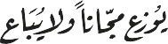
2019 ``` 1441 á©ÑW

`g 1430 , º«∏©àdG IQGRh
������ ������ �������� ��� ���� ����� ������
������ ����� ������� ���� � �������� ���� ���� �������� ������
������� ������� � ������� ����� �������
�� ���� × �� � � ��
��� � ���� � �� � ��� � � � �����
�������� � �������� ������� � � ������ ��� � ������� ������� � �
���������
������� � � ������ ��� �
��� � ��� ����
ì
1428/6356 : ´GójEG ºbQ
978-9960-48-496-9 : ���Q

���� ����� ��� ������ ������� ����

IEN.EDU.SA

������� ������ ������ ��������� �����


FB.T4EDU.COM

.




7 - 6
������G ��ó��
������� ���� ������� ������
�á������ ���� �á������ ������

������ �������� ������


���������

áëØ°üdG | ���ªdG | ´°VªdG º°SG | ´°VªdG
13 - 10 | º°SôdG | �º°S�� ��� | ���G ´°VªdG
17 - 14 | º°SôdG | ���ª�ªdG ��� �ô��� »��� | »fÉãdG ´°VªdG
21 - 18 | º°SôdG | �»�°üb º°SQ�G | ådÉãdG ´°VªdG
25 - 22 | º°SôdG | �á����dG »� �Gd�G | ™HGôdG ´°VªdG
26 | ��ó�dG ºj��

áëØ°üdG | �É�ªdG | ´°VªdG º°SG | ´°VªdG
31 - 28 | á�ô��dG | �QGô��dÉH á�ô��dG | ���G ´°VªdG
36 - 32 | á�ô��dG | ���É��dÉH á�ô��dG | »fÉãdG ´°VªdG
37 | ��ó�dG ºj��

��������� ������� �������� ���� �á©����� ������
�á��Ñ��� ���� �á������ ������

áëØ°üdG | �É�ªdG | ´°VªdG º°SG | ´°VªdG
43 - 40 | á�É��dG | .�É�°��ÉH ���dG ™���G | ���G ´°VªdG
48 - 44 | á�É��dG | .��eÓe �G� � É�°��G ™���G | »fÉãdG ´°VªdG
49 | .�ó�dG ºj��

áëØ°üdG | �É�ªdG | ´°VªdG º°SG | ´°VªdG
55 - 52 | �ÉeÉ�dÉH ���°��dG | . OÓH øe | ���G ´°VªdG
61 - 56 | ø��dÉH ���°��dG | .ó�Øe ø��dG | »fÉãdG ´°VªdG
66 - 62 | ø��dÉH ���°��dG | .ø��dG øe � É�°��G ™�°��G | ådÉãdG ´°VªdG
72 - 67 | �ÉeÉ�dÉH ���°��dG | .�ó�Øe á�f�ô�dG ���dG | ™HGôdG ´°VªdG
73 | .�ó�dG ºj��
áëØ°üdG | ´°VªdG
82 - 77 | .á��ØdG �É��dG� á�ë�°V�dG �É�°��G �Sô��


á������
�d�G ���� �ó�dG »�f ��� �Ó°�dG� �Ó°üdG� �ø���°�f �H� �ø�ªdÉ�dG �Q � óªëdG
:ó�H� ..ø��ª��G ��ë°��
��Ée��e �Gô���E -�dÉ�dG �j�� �jój ø�H ���dG- �É��dG G��� ºª°� ó��
ÉªH ���ôe ���� .áØ���ªdG á��ØdG á�Hô�dG �É���e »�� ���GQÉ���e� ��Gô���
�Ée��ªdG øe ���� ����G »°SGQódG �°üØdG �É���G á��ØdG á�Hô�dG �S�QO »� ��ª���

�ü°ü�ªdG ���dG ��ëe »� ó�� .Éª
�e É�� ªjOÉ��G �É��ôe ����j Ée á�°�f G�

:»dÉ�dG ë�dG ��� �°Vô� �Gó�� ™HQ�G »fÉãdG »°SGQódG �°üØ�d
:á�dÉ�dG ™�°VGªdG �d�É�� ób� �º°SôdG �É�e �G��H »�� �d��G �ó�dG �
�º°Sôf ��� :���G ´°VªdG
.��ª�ªdG ��� �ô��� »��� :»fÉãdG ´°VªdG
.»�°üb º°SQ�G :ådÉãdG ´°VªdG
.á����dG »� �Gd�G :™HGôdG ´°VªdG
:á�dÉ�dG ™�°VGªdG øe ����� �á�ô��dG �É�e �G��H »�� á�fÉãdG �ó�dG �
.QGô��dÉH á�ô��dG :���G ´°VªdG
.�OÉ��dÉH á�ô��dG :»fÉãdG ´°VªdG
:á�dÉ�dG ™�°VGªdG øe ����� �á�É��dG �É�e �G��H »�� áãdÉãdG �ó�dG �
.�É�°��ÉH ���dG ™���G :���G ´°VªdG
.��eÓe �G� É�°��G ™���G :»fÉãdG ´°VªdG
á�HQ�G øe ����� �º°��ªdG� ��°�ªdG ���°��dG �É�e �G��H »�� á�HGôdG �ó�dG �
:»dÉ�dG ë�dG ��� ™�°VGe
. OÓH øe :���G ´°VªdG
.ó�Øe ø��dG :»fÉãdG ´°VªdG

.ø��dG øe � É�°��G ™�°��G :ådÉãdG ´°VªdG
.�ó�Øe á�f�ô�dG ���dG :™HGôdG ´°VªdG
�á��É°VEG �Ée��e� �»°SGQódG �°üØdG G�� »� �ójó� ™�°VGe É���ª� �ó�� �°S
.É�ª��� ��°S »�dG º��ÉØªdG� ��Gô��dG ��ª��d á��Gô�EG á�°�f�G� �á��ª� �É������
ø�°�ë� ��dEG �ó�j ��dG ó��dG G��H É�HÓ� ™Ø�j ��G ºjô�dG �G ��É°�f �É��dG »��

.áHÉ��°SG� É�
É�fEG áØ���ªdG »�ØdG ô����dG �É�ªd º��°SQÉªe� º�ª���
.ø�ªdÉ�dG �Q � óªëdG ��G ÉfG�O ô��G�

اﻟﻮﺣﺪة ا وﻟﻰ: ﻣﺠــﺎل اﻟـﺮﺳــﻢ

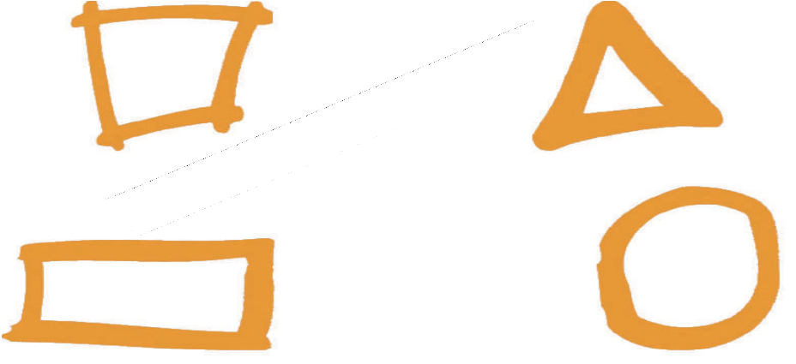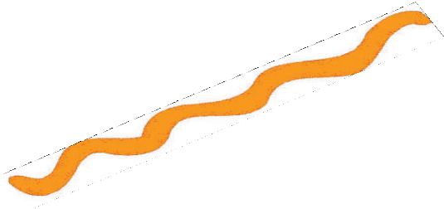


:�ó�dG �É�°Ve
�º°Sôf ��� ���1
.��eÓªdG ��� �ô��� »��� ���2
.»�°üb º°SQ�G ���3
.á����dG »� �Gd�G ���4

9


»ªbôdG ¢SQódG §HGQ
www�ien�edu�sa
����� ��������
�
`



.�É°��H áëØ°� ��� óªëe É���f á��ª� á��f �É�� �É� �f�G ��ëj
.�É°���dG áëØ°üdG �É°�� »� �Ébó°��G É�d ���d �ó��� �fÉ�
�»�e ���j øe ó��G  �ó��� Éf�G G�Éªd :��É°��� É��ô�� óªëe É��°�f
.�Óª�ªdG á�°S »� É����j� ábQdG ��ª�� ó��G É��dEG ����j �G �É���
.�Gd�G á��� ��e� �ô��G �ôe óªëe �É� ..ô�Ø� �fÉ� Éª��H�
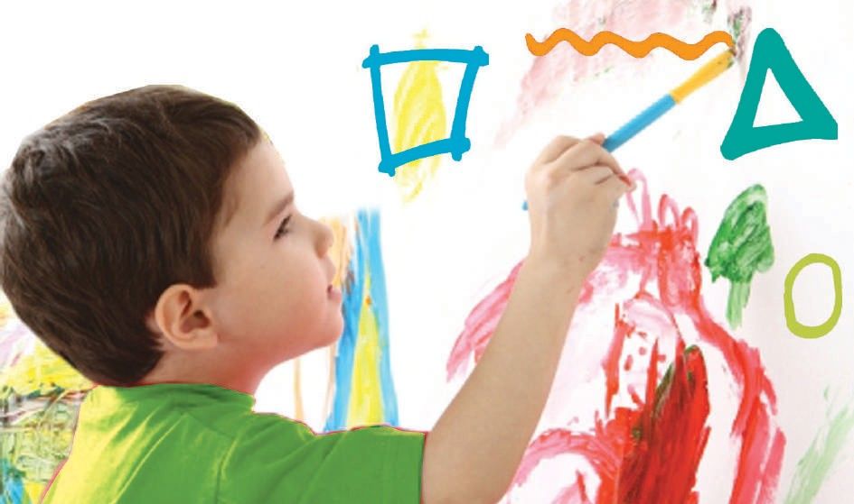�ô��G É��f óªëe º°Sô�°S� ��Ébó°��G É�d ó��°S É�f�G ��ô�� á���dG ��ô�
.º°Sôj óªëe:�1� ��°�dG
.�1) ��°�dG �ÉfGdG� � É�� ���
10

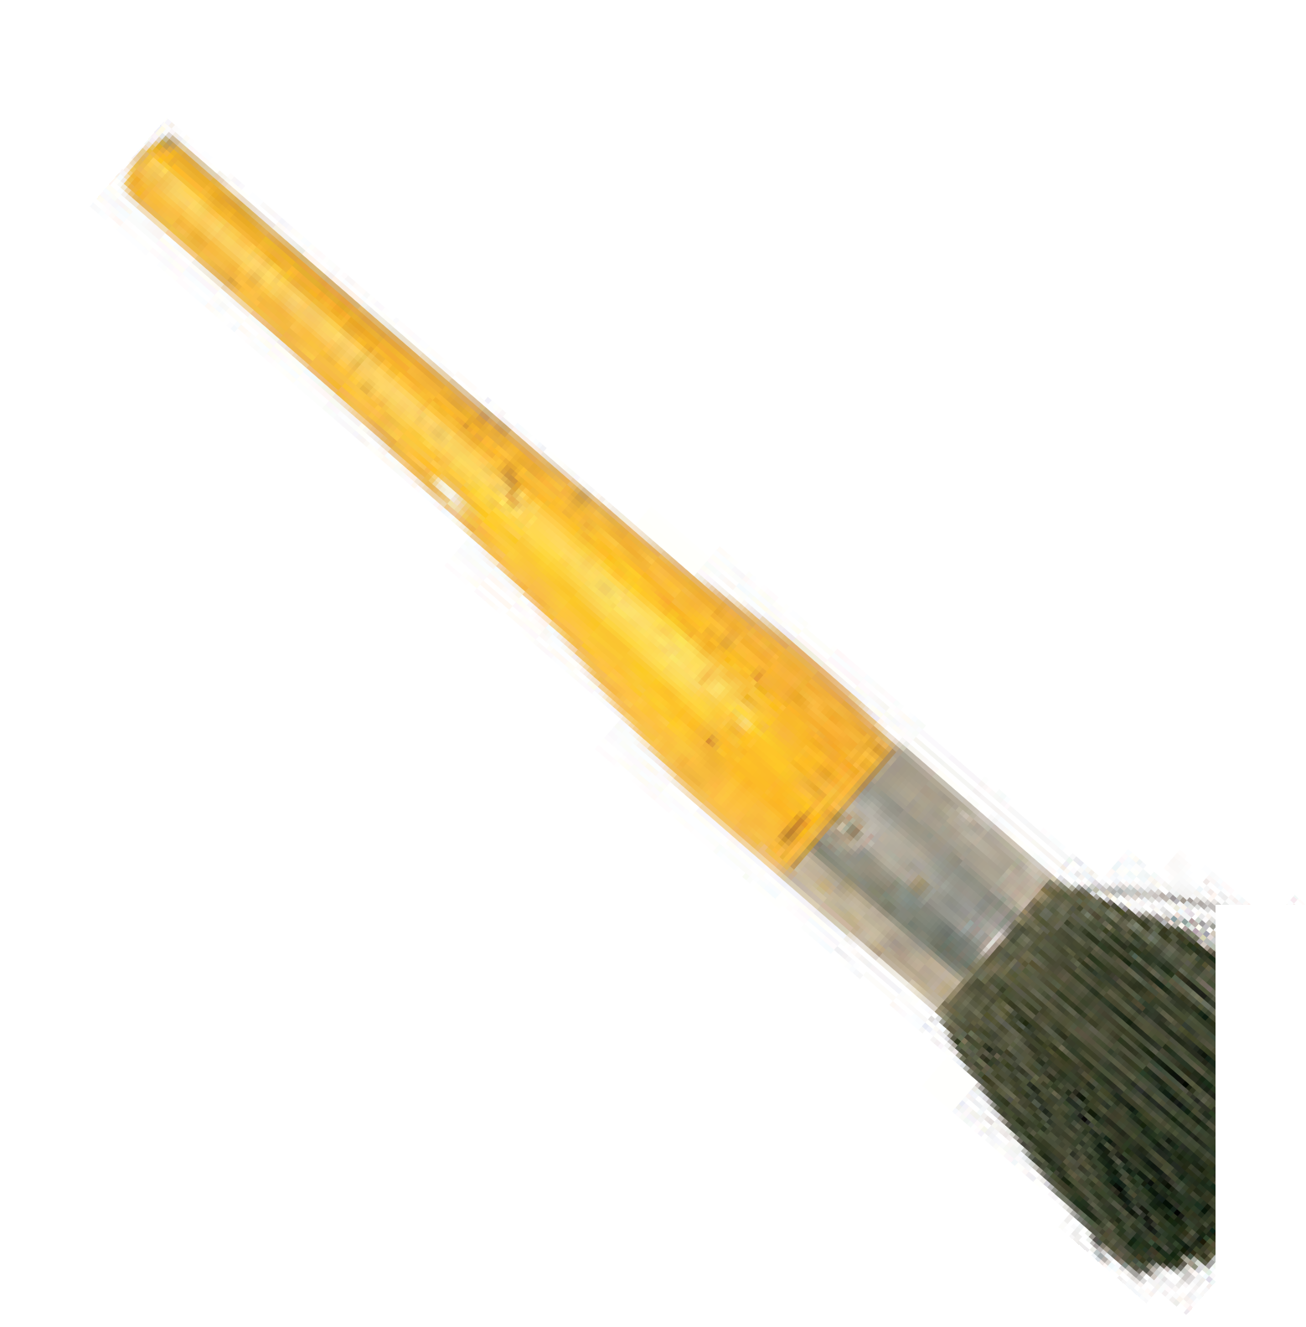.�2) ��°�dG �É�� �É��dG �ë�°��G ��� á��f� á��f º� ��ô��G á��f óªëe ™°V�


.§� »� �É��dG ™ª�� :�2) ��°�dG

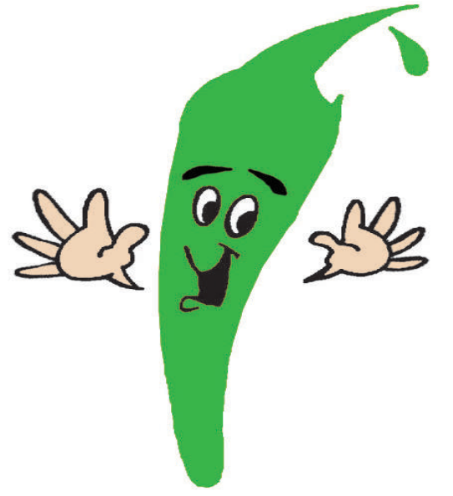�ô�� É�f� Gô�ã� �É��dG ��ô�
.óªëªd �óë�j §�dG :�3) ��°�dG
É�f�G� �á�Éª�dG »� ��dG ��G
���°S §� »� ™ª��� Éeó��
§�dG ø�d .ô���G �ó�É� É�d
É�d �Éb� á���dG ��� ¢Vô��G Éf�G� ���G �Ébó°��G� á�Éª� º�fG� G��QÉ� ����°V� ó��� §�
º°Sôj ��G Góªëe OÉ�f º��°�
.�ô��G É��� »d

11

.�Ébó°��G ��O Gó
��� »��ô��  óªëe Éj :É�� dÉ� ��°� §�dG ™�Q
:ójó� øe º°Sôj OÉ�� óªëe ��ª°S

.���fG ��� ��� �ó� º� �ô��G É�� º� �ô��G É�� º°SQ
.�4) ��°�dG ��ó� G�Ée G�ô�fG
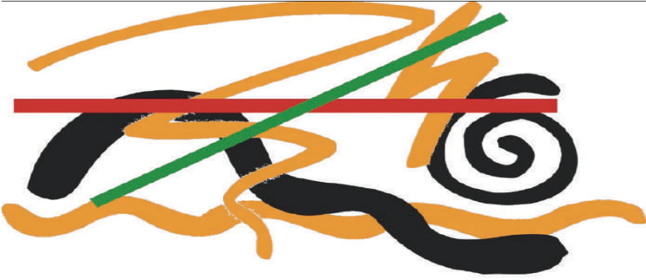
.á��É��e ��� �ó�d º°SQ :�4) ��°�dG
.�É�� �f� Góªëe �ô�°�� �ó��°S »�� ���dG ��ª��G
:»dÉ�dG QGëdG º���H QGO�
.ø�bôØ�e É�d� á�Éª� Éj :º���°�ªdG §�dG �Éb
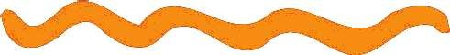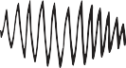��ª�f G�Éª� ��ë°� G�� :�ô��ªdG §�dG �É��
É��ª�j ��G óªëªd ��f ��ô�� ó�� :ô°���ªdG §�dG �É°�
.¢���dG É�°��H ™e �É�°��G »�
.óªëe ��� G�OÉ�� �ô°���e Éj ��°���G :�Éb� »�ë�ªdG §�dG OQ

12

�É�°��G �f�� ��� �É�°��G �dEG É�d
ëj� ����dG ™ª�j �GóH� óªëe º��ª°S
.�5) ��°�dG �á�dÉ�dG

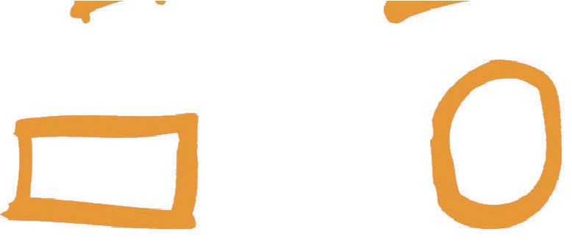.™HôªdG å�ãªdG
.å

.����°�ªdG
.�ô�GódG

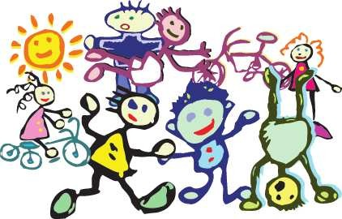

.���dG ø� ���f »�dG �É�°��G :�5) ��°�dG
Gô�°�� �á����d Gô�°�� ��É��dG �ª��G É��e º°Sôf ��G ™���°�f á��ª� �É�°��G É�fEG
:�É�°��G� §�dG º°Sôf ��� É�ª�� �dG ô�ÉªdG �É°SôdG óªëªd Gô�°�� �§��d
.�É°���dG »�°SGô� »� �É�°��G ��ª��G ��� G�ó�É°�
13

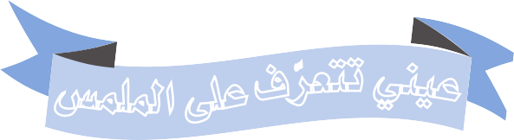
»ªbôdG ¢SQódG §HGQ
www�ien�edu�sa
J
»fÉãdG ´°VªdG
dG

��j �CG ÉeEG �����e ¢�ª�e �d í£°S ��� �»�QÉ� í£°S É�d �É°��CG ™�ª�
.(8) ��°�dG �É�FÉ°T �CG ,(7) ��°�dG ,É�� °�� ÉeEG� ,(6) ��°�dG ,ÉªYÉf
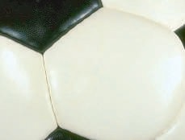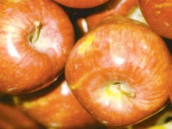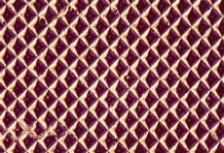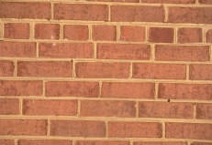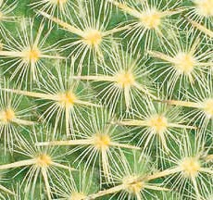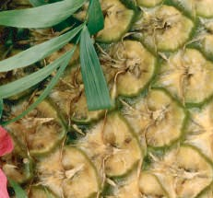

.áªYÉf í£°SCG :(6) ��°�dG

.á�°�� í£°SCG :(7) ��°�dG

.á�FÉ°T í£°SCG :(8) ��°�dG

.í£°SCG ���d ¢�ª�ªdG ´f É��ôY ¢�ª�dG á£°SGH
.É���YCÉH �Gôf Éeó�Y ¢�ª�ªdG �ô�f É�ë�°�CÉ�

14

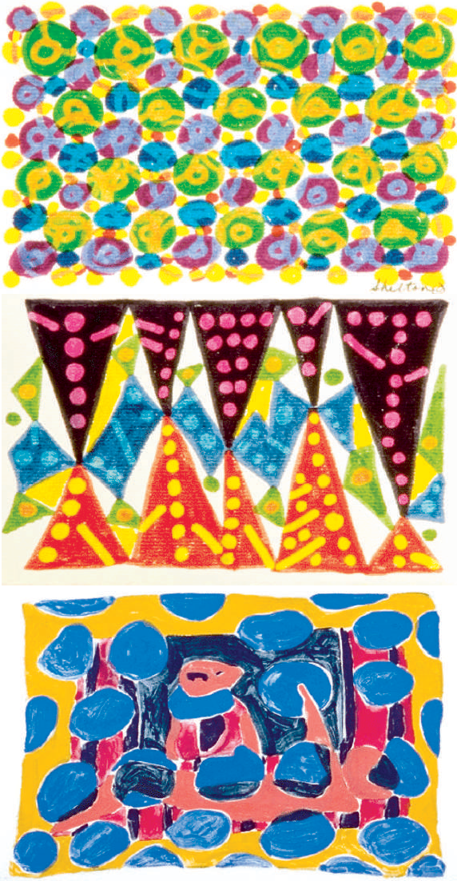

øY ô��f �CG ™�£�°�f �GdCÉH�
.(11 ,10 ,9) �É�°TCG ,¢�ª�ªdG
.¢�ª�ªdG øY ô�����d á�fd á�d :(9) ��°�dG

.¢�ª�ªdG øY ô�����d á�fd á�d :(10) ��°�dG

.¢�ª�ªdG øY ô�����d á�fd á�d :(11) ��°�dG
15

.�GdCG øY á��Éf á�HÉ°�dG �°SôdG »� »�dG ¢�eÓªdG
¢�ª�e CÉH �CG ,ø°�� í£°S �� ábQ� ��Y Éf� d� ¢�É°�ôdG º�b É�eó��°SG d
:(12) ��°�dG ,¢�ª�ªdG G�� ô���°S
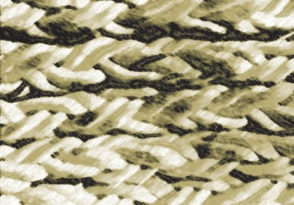
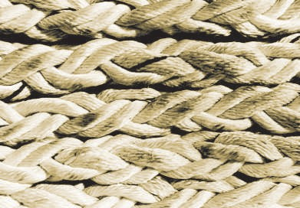
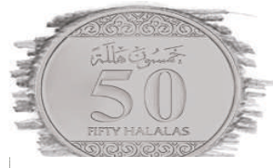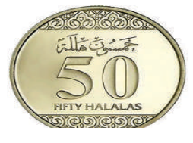

.��QÉ�dG í£°SCG ��Y º°SôdÉH ¢�eÓªdG :(12) ��°�dG

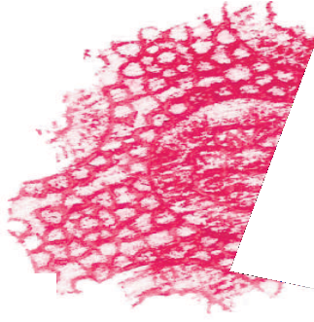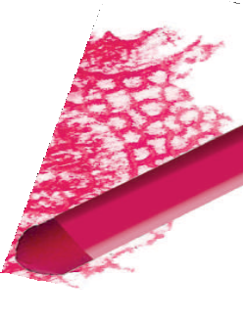.(13) ��°�dG ,¢�ª�ªdG º°Sôf �CG É°�jCG ™�£�°�f á��ª°�dG �GdCÉH


.á��ª°�dG �GdCÉH ¢�ª�e :(13) ��°�dG
16

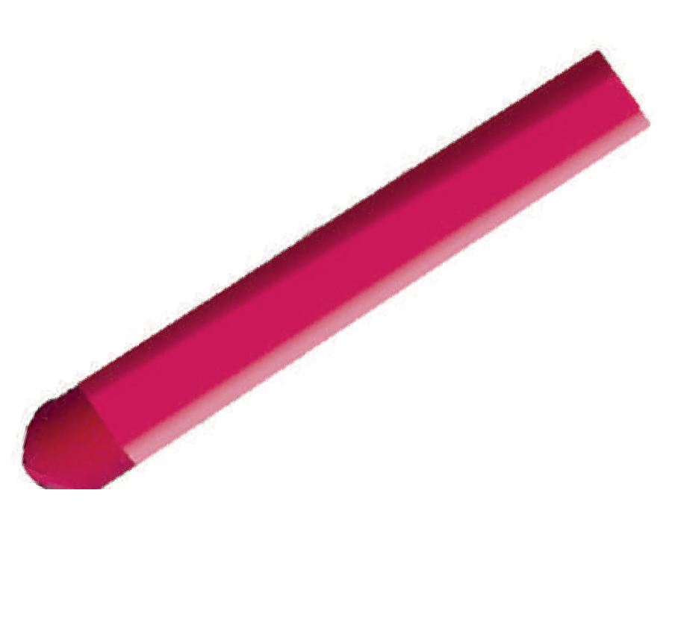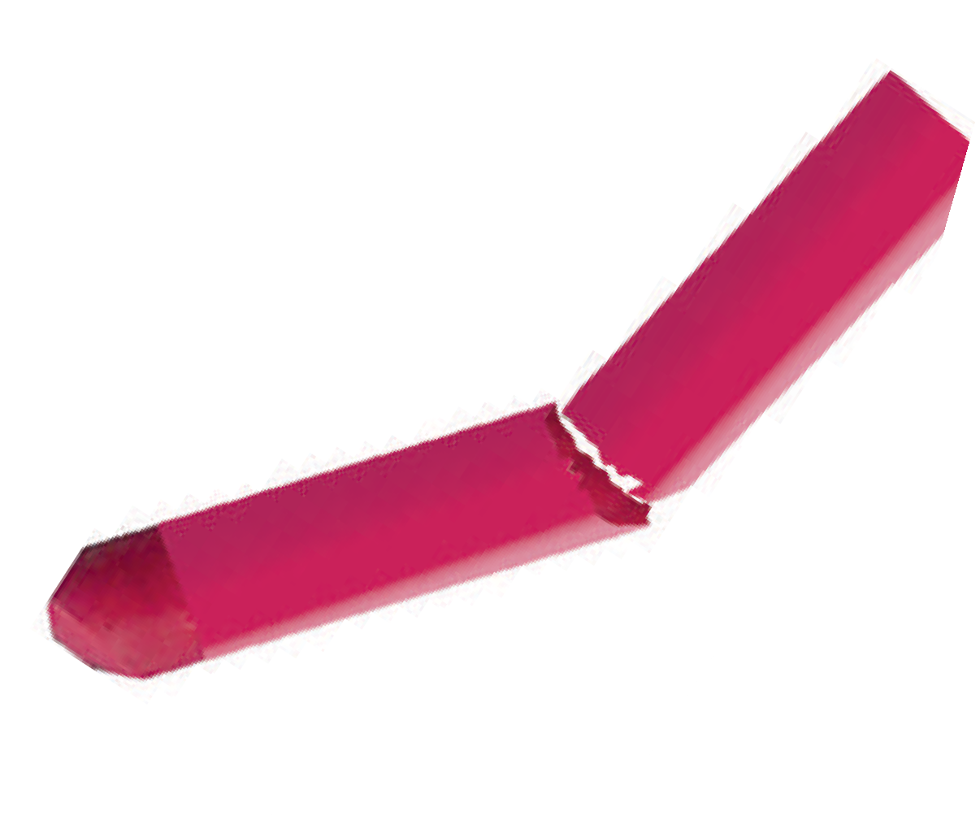:(14) � °�dG ,ô°����  ��� á��ª°�dG �GdCÉH ájÉ��dG ��j

.á��ª°�dG �GdCG ��Y á��ÉëªdG :(14) ��°�dG
.Gó

�� »fGdCG ��Y ��É�CG ÉfCG

Éeó�Y ,(15) ��°�dG ,¢�eÓªdG øe ójó�dG É��� ø�� HCG á��ª� á�d º°SQCG �CG »���ªj
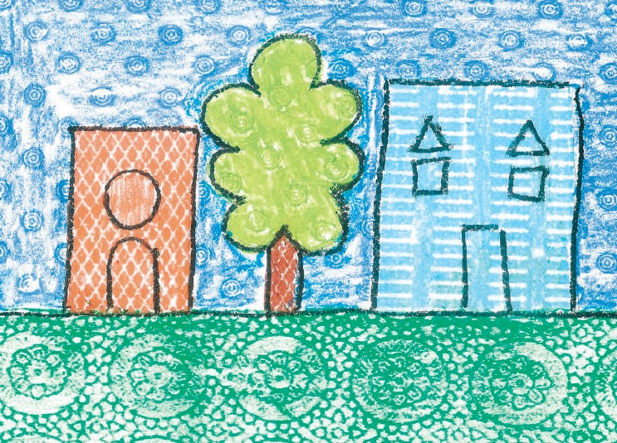.����e ¢�ª�ªH í£°S ��Y »�bQ� ™°VCG É��e ��� �� �� dCG
.¢�eÓªdÉH á��ª�dG »��d :(15) ��°�dG

17

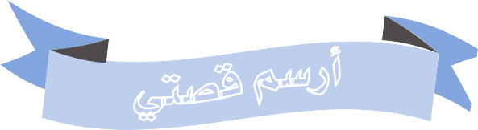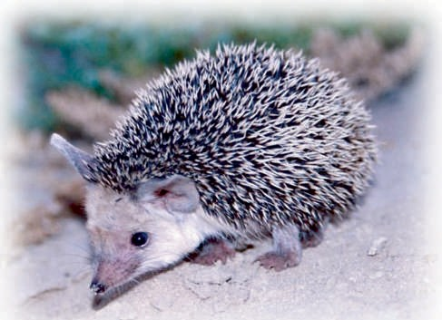
»ªbôdG ¢SQódG §HGQ
www�ien�edu�sa
»
C
ådÉãdG ´°VªdG
G
.òØæb :(18) ��°�dG

,(18) ��°�dG ,òØæbh ,(17) ��°�dG ,§bh ,(16) ��°�dG ,¢ShhÉW á�ó°� ™ª��G
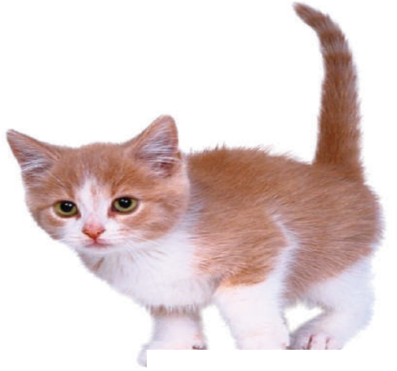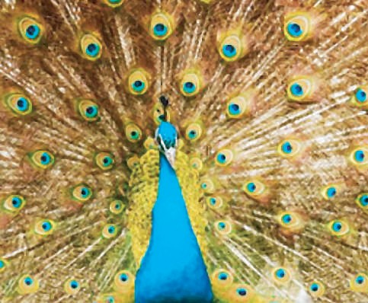.�jô£dG ��Y
.§b :(17) ��°�dG
.¢ShhÉW :(16) ��°�dG

18

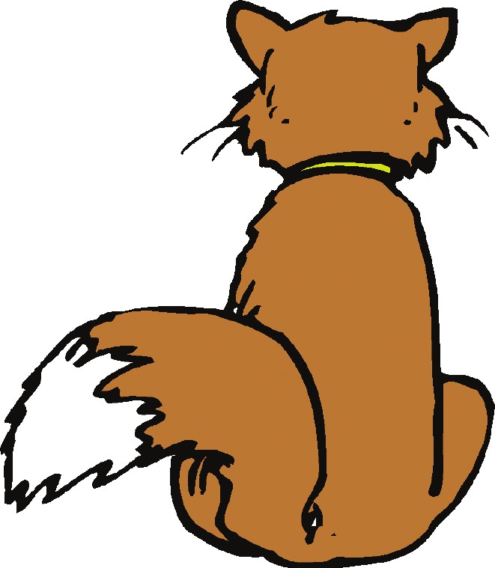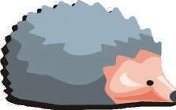

.ô��G »� ø�ª�j º�æe ó�Gh �� CGóHh

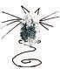
�¢ShhÉ£dG É�jCG »dEG ô�æ� G�Éªd :¢ShhÉ£�d �Éb
�CG ô�Ø� ��� ,ôFÉW ÉfCGh ��ª� ºYÉf ô�°�H §b �fCG :ÓFÉb 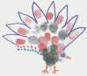 �É�CÉ�
�»æ��CÉ�

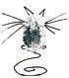
.»æ��YCG ��ªdG �°�jQ ø�dh  :�Éb

.QCÉØdG ��°TCG »æfC ÉfCG »æ��CÉ�°S G�� EG :ÓFÉb 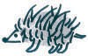 ��ó�
,¢ShhÉ£dG ���G  ÉfCGh ,�Ébó°�CG øY åëHCGh ,ó��h ÉfCG áYÉª� Éj :�É��
.GóHCG òØæ�dG ���G h
�Ó��b ô�� ,�FÉ°�dG ó��dG ��É°� Éj òØæb Éj ����G ���h
.��dG �d� òæe º��bGó°� �CGóHh ™�ª�dG �ë°V É�óæY
�»�°üb �ª°SQ ��� º��� �� ø�dh

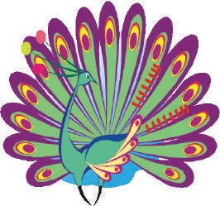
19

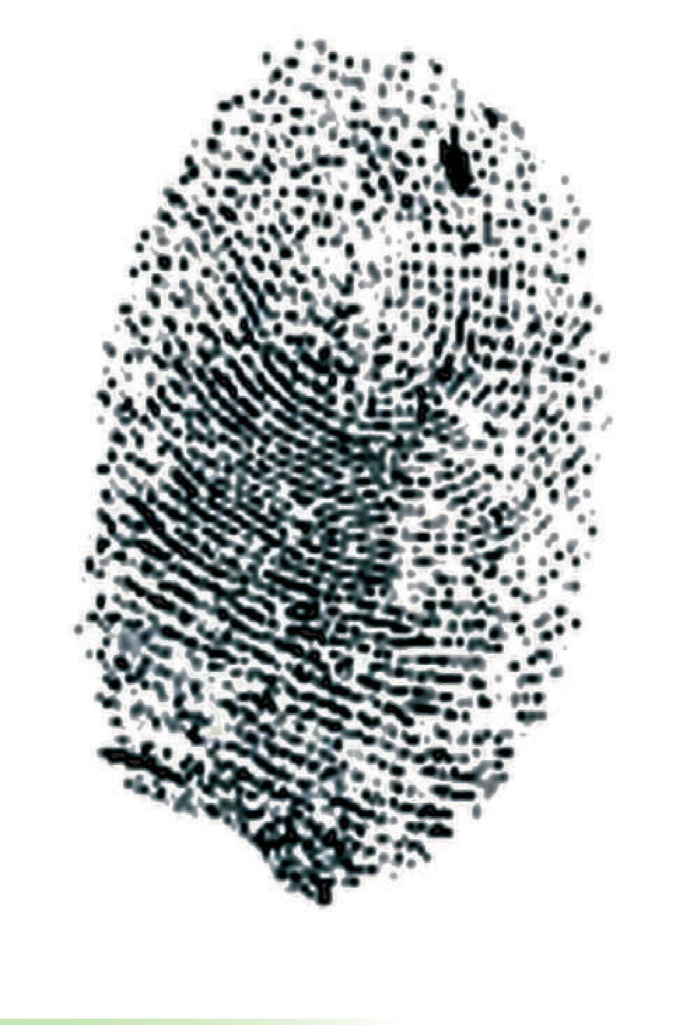:��� º�ª�YCÉ°S
.™�°�EG áª°üH :(19) ��°�dG
.™HÉ°�CG Éª��� øjój �G Éæ��h
.(19) ��°�dG ,áª°üH ��� ™�°�EG ��

����W º� ,�É�ª�dG »� �Gò��e ��H ™�°�e ¢TÉªb �H øë°� »� »��°�EG ��°Vh
�É�°TCG øe ��°T �dEG �ë��d �£�dG ¢��H �ª°SQ �d� ó�Hh ,ábQdG ��Y
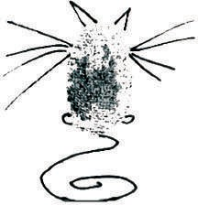
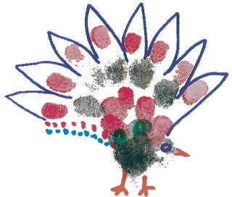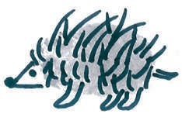.(20) ��°�dG ,òØæ�dGh §�dGh ¢ShhÉ£dÉ�


.áª°ü�dÉH º°SôdG :(20) ��°�dG
20

§��d G�QÉ��d á��ª�dG �ÉfG�ëdG øe áYª�e ™ª��G ÉeóæY á°ü�dG ���fG
.�Ó°�H º�°��H ™e º�°��Yh º��bGó°� ¢ShhÉ£dGh òØæ�dGh
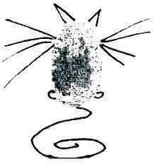
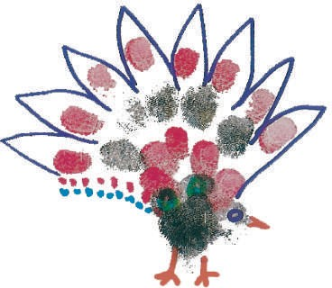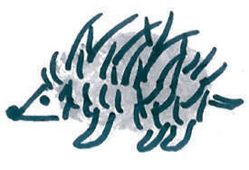

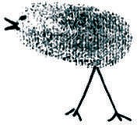
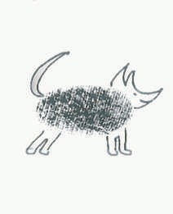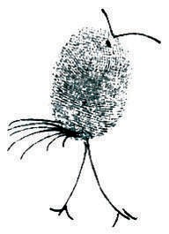ÉW£� É��� �ó��°�f ,á��ª� á°üb º°Sôæd �Oó��e �GdCG �Gó��°SG É°�jCG Éææ�ªj
.á��ª�dG ábGó°üdG :(21) ��°�dG

,áã�ãeh á��jô��FGOh á�Hôe 
É���°�TCGh , ô��FGó��dGh �ô
��ªdGh º���°�ªdÉ� ,áYæ�e

.(21)��°�dG ,òØæ�dG �°Th §�dG ô�°T áe�æ� ¢�eÓªdG É��� ô���h

21

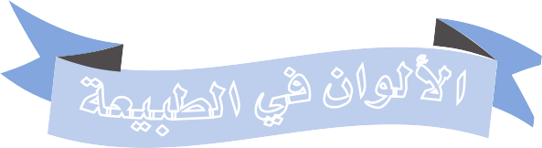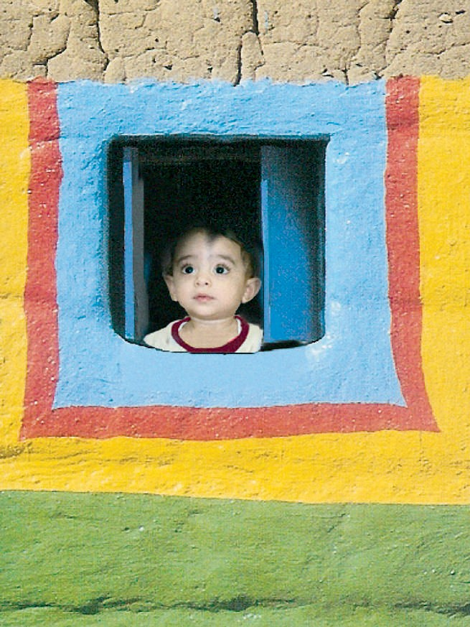
»ªbôdG ¢SQódG §HGQ
www�ien�edu�sa
HGôdG ´°VªdG

Ñ
á�ØW �Øbh
ô�æ� �ô��°�
�ò�Éf ô�Y á°��óH
,�Éª°�dG �dEG �ô��°�
.(22) ��°�dG
�æ� �É�� »� �ô��°üdG É��jôb »� Gô£ªe �É� �dG
.á��ªªdG
.É��ª�CG Ée �G Éj :á°��óH �ô��°üdG ��É°�
�æ�h ,�Éª°�dG »� ô�£j �GdCG øe É°Sb �ô��°üdG �CGQ
.ójó� ôFÉW �fCG
:(22) ��°�dG
á°��óH ô�æ� á�ØW
.�ò�ÉædG ô�Y

22

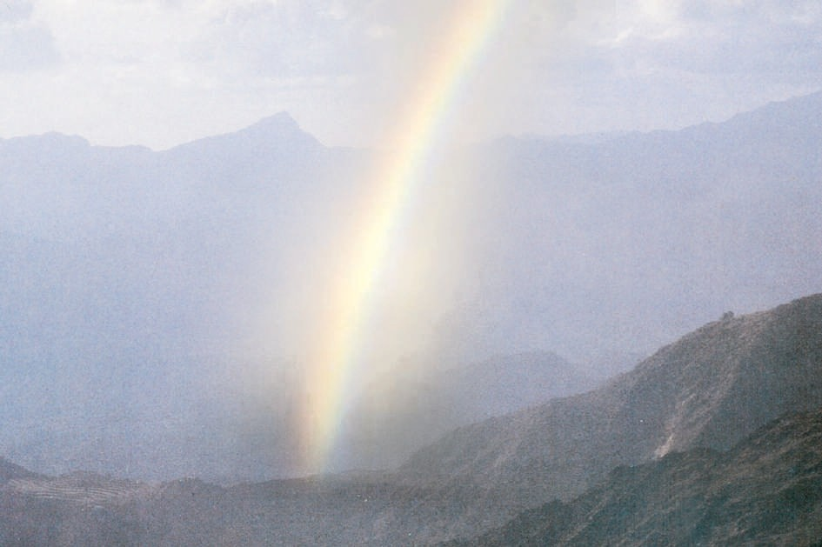.ô£ªdG ¢Sb :(23) ��°�dG
.É��ódGh ��É�� �GdCG �ò� �dEG ô�æ� ���
�»eCG Éj ô�£dG Gò� º°SG Ée :É��ódGh �dCÉ°��

.(23) ��°�dG ���b ¢Sb �fEG ..Gô�W ¢��d Gò� :É��ódGh É�d �dÉb
:�GdCG á��°S É�OóYh á�ÉØ°�dG á��ª�dG �GdCG øe áYª�e �fEG
ô�°�CG� ��É�J�dG� �ôª�CG ¿�dG

�»�°ù�æÑdG� �»�«ædG� ��Q�CG� �ô°�� G�

.¢�ª°�dG �°V Q��h ô£ªdG ó�H �GdCG �ò� »�CÉ�
.áØ��f QÉ�°TCGh ¢VQCG �CG ó�CÉ�� »�d Éæ� É�fEG
23

.(24) ��°�dG ,��b ¢Sb á°üb »� �ò�


.ô£ªdG ¢Sb �GdCG :(24) ��°�dG
.�GdCG �ò� �Gó��°SÉH �bCÉ°Sh ,�GdCG �Éª°SCG ��b ¢Sb øe �ª���
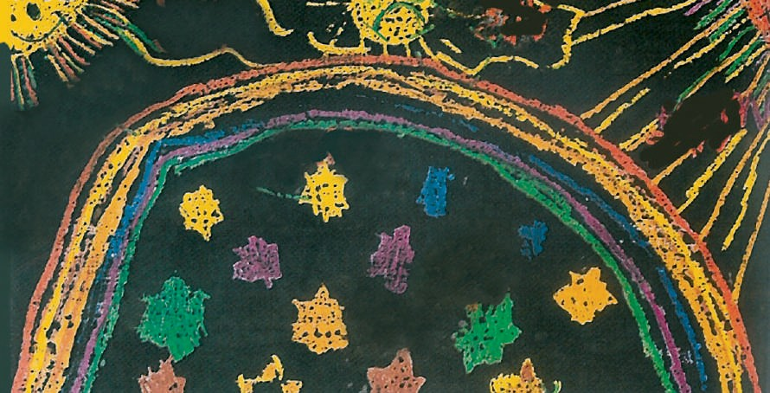
.ô£ªdG ¢Sb º°SQCG :(25) ��°�dG
24


.�É��dÉH øj��dG :(26) ��°�dG


�É°�f
á�FÉªdG �GdCG �Gó��°SÉH øj���d »�óYÉ°�e ��æªdG »� QÉ��dG øe ��WCG
É�°��H ™e §����h ��°�� É����CGh ,��b ¢Sb �GdC �ÉªdG �É�H ��GO
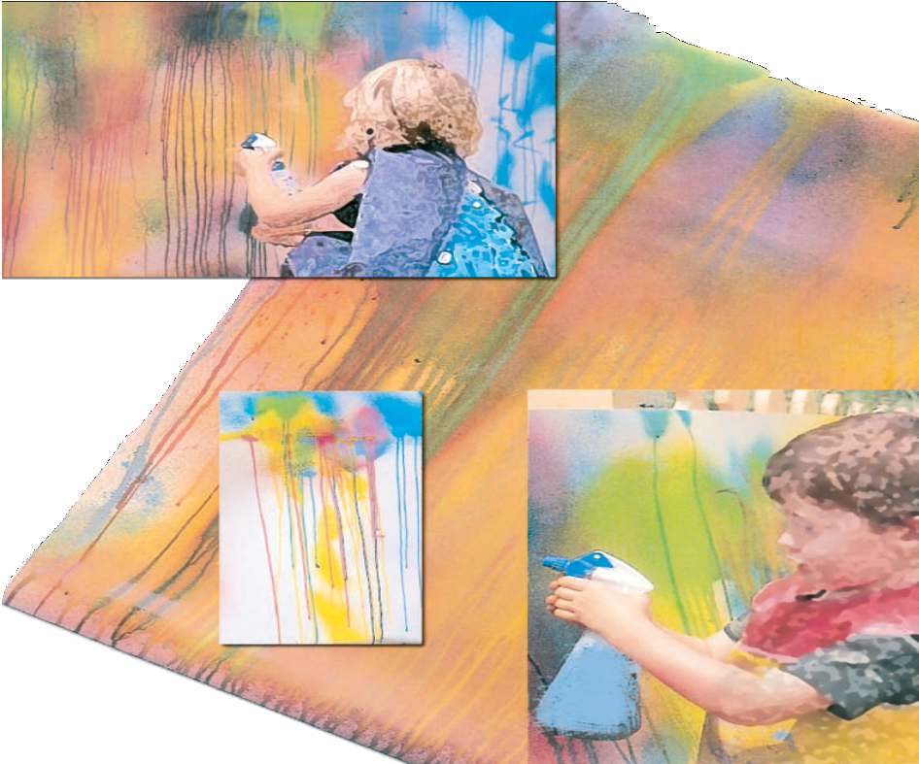
.(26) ��°�dG ,¢���dG

25

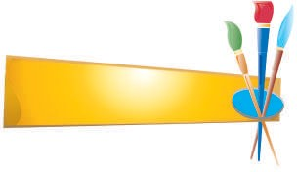:�ª°�ªdGh ��°�dG ø�H »�� °�/�°�

�ó�dG ºj��
1
.ô°��æªdG §�dG
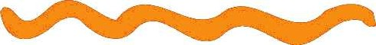
.º���°�ªdG §�dG 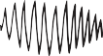 .»æëæªdG §�dG

.�ô��ªdG §�dG

:��b ¢Sb �GdCG �É�ª°�e �GôØdG »� »�� ��G/���G
2

:É��°SÉæj Éeh áª��dG ø�H »�� °�

/�°�
..............................................


..............................................

..............................................

..............................................

..............................................

..............................................

..............................................

�í£°SCG �ò�d ¢�ª�ªdG ´f �ô�� ��
3

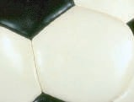
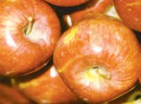
.á�FÉ°T í£°SCG
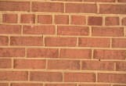 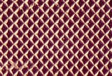 .áªYÉf í£°SCG
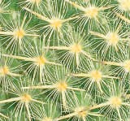
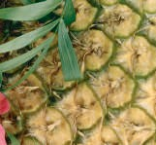
.áæ°�� í£°SCG

26

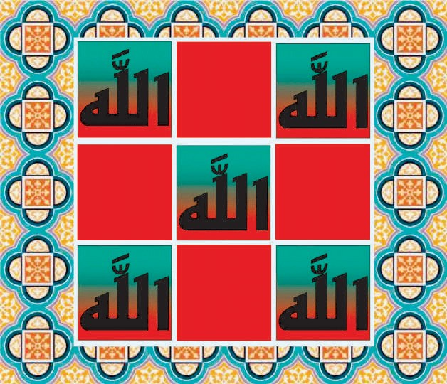

:�ó�dG �ÉY°Ve
.QGô��dÉH á�ô��dG ���1
.�OÉ��dÉH á�ô��dG ���2


اﻟﻮﺣﺪة اﻟﺜﺎﻧﻴﺔ: ﻣﺠــﺎل اﻟﺰﺧﺮﻓﺔ

27

�£�dG óY ™�£�°�f �� ,áf
�e �£� É�ª°�� ��Yh á�ª°�dG �ò� �G ���
.(27) ��°�dG ��GôØ°üdG


»ªbôdG ¢SQódG §HGQ
www.ien.edu.sa
QGô�àdÉH áaô��dG
��CG ´°VªdG
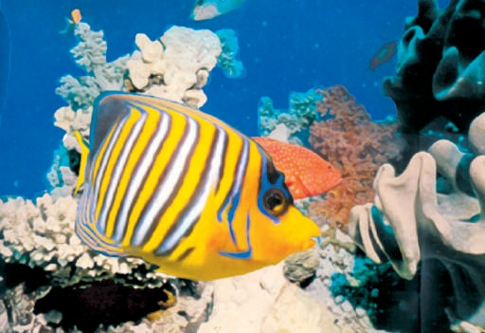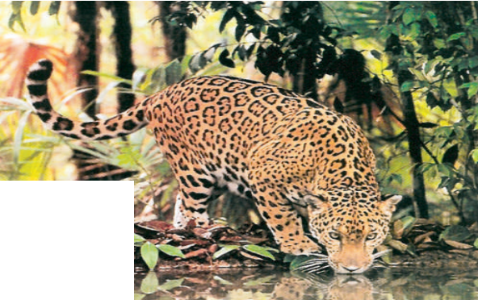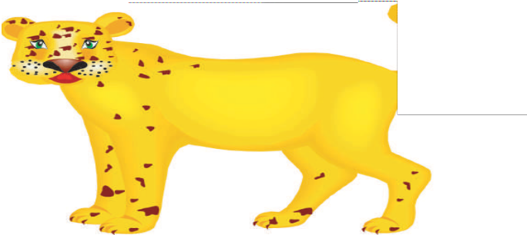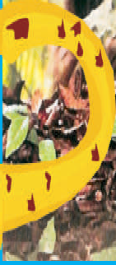
™�H �ó�� ��Yh ôªædG Gò� ���h
�� á�HÉ°��eh �Oó��e �GO°S
.(28) ��°�dG �É�óY ™�£�°�f
™�£�°�f �� á�æ�dG ���H ôªædG Gò� ó��
.(29)��°�dG �É�æj��h É�ª°SQ
.ôªf :(28) ��°�dG
.á�ª°S :(27) ��°�dG
.á�æ�dG ™��dG ó�� ôªf :(29) ��°�dG
28

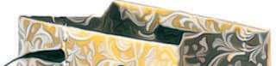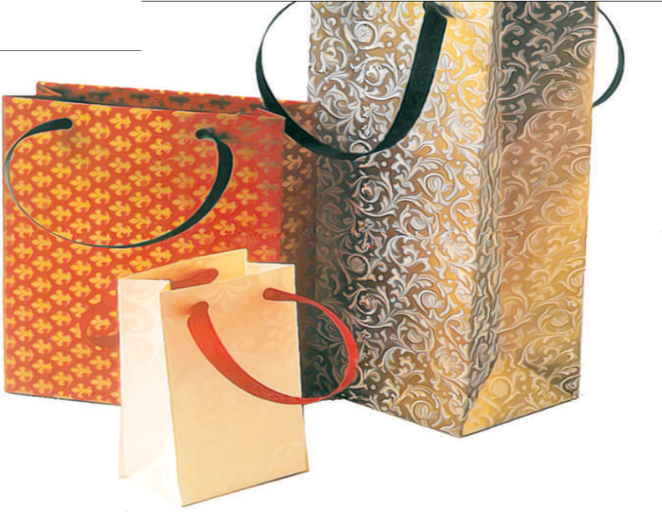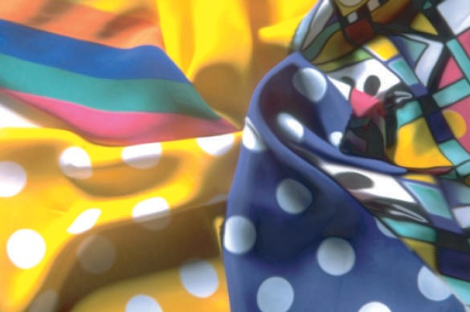

�óY ��°�dG �OÉYEG � :QGô��dG
.(31 ,30) �Ó�°�dG ,�Gôe

.QGô��dÉH á�ô��dG É��� ô��j á°�ªbCG :(30) ��°�dG

.QGô��dÉH á�ô��dG É��� ô��j ¢SÉ��CG :(31) ��°�dG
29

.á�HÉ°��e �É�HôªdG
.�É�HôªdÉH QGô��dG :(32) ��°�dG
.ájhÉ°��e �É�HôªdG
.ó�Gh ��H �É�HôªdG
.(32) ��°�dG ,ÉjOÉY GQGô�� �Qô��e �É�HôªdG


(1) �É°�f

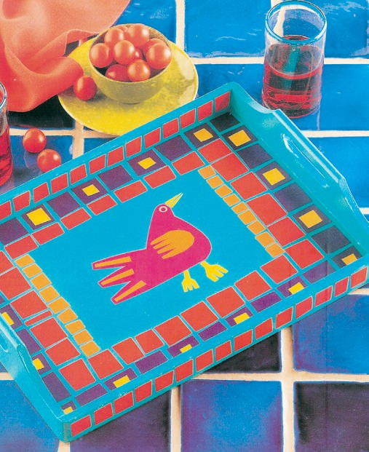.(33) ��°�dG ,ó�É°�f
.á�æ�°� »� »�ô�� QGô�� :(33) ��°�dG
»� QGô�� ó�j ��
��O�ªdG �QÉ��dG

30

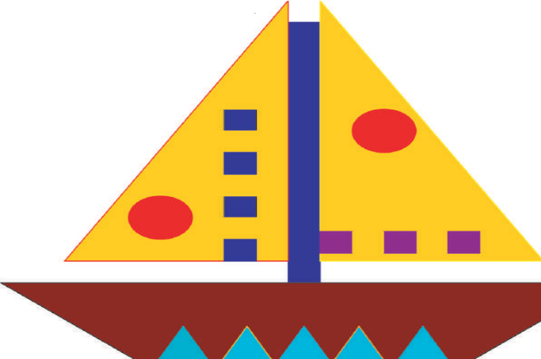
.��ªdG �QdÉH »YGô°T ��ôe :(34) ��°�dG


(2) �É°�f
:(34) ��°�dG ,á�YGô°T ��Gôe ��ªdG �QdÉH Éæ°�ØfCÉH ™æ°üf

31


»ªbôdG ¢SQódG §HGQ
www.ien.edu.sa
��ÉÑàdÉH áaô��dG
»fÉãdG ´°VªdG

.á��ô��dG �É�°TCÓd QGô��dG Éæ°SQO
�á�ô��e �GQGô�� �����dG �GQhCG »� ó�� ��
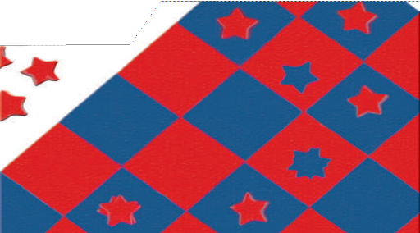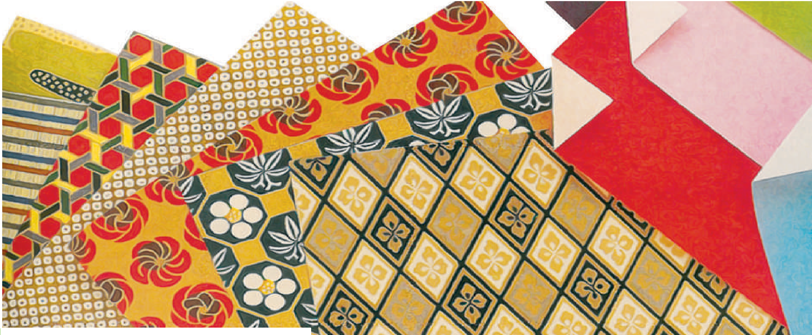.(35) ��°�dG ,ájhÉ°��e �É�HôªdG
,á�HÉ°��e �É�HôªdG
.(36) ��°�dG ø�f�H �É�HôªdG
.ø�Ø���e
�Qô��e �É�HôªdG
.� OÉ��e GQGô��
.»f�dG �OÉ��dÉH á�ô��dG :(36) ��°�dG
.�����dG �GQhCG »� á�ô��dG :(35) ��°�dG

32

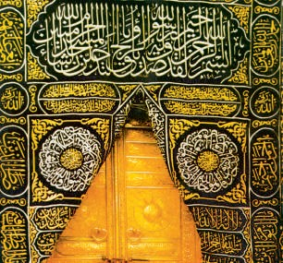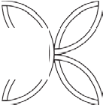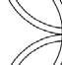
.(37) ��°�dG ,�GôªëdG �É�HôªdG »�
(1) �É°�f
É��É�f Ó� �°T º°Sôf
.á��ô�� ô°�ÉæY á�Hô�dG �ÉHÉ��dG
,á�f�Gô�dG �Éj�G øe �ÉHÉ��H á���dG �ÉH øj� �
.(38) ��°�dG
.�QÉ�� øe �H Éeh á�ô°�ªdG á���dG �ÉH :(38) ��°�dG
.ájhÉ°��e �É�HôªdG
.��dG »� áØ���e �É�HôªdG
.��°�dG »� áØ���e �É�HôªdG
.��dGh ��°�dG �Ó��ÉH ádOÉ��e �GQGô�� :�É�HôªdG �GQGô��

.�OÉ��dÉH �É�HôªdG QGô�� :(37) ��°�dG
33


2

.ádOÉ��e �GQGô�� Éæ�£��d á��°�ædG �ô�dG á�jô£H á�æ�� ábÉ£H Éæ°�ØfCÉH ™æ°üf
.��e �Qh �
.�Gô�h ¢ü�e �

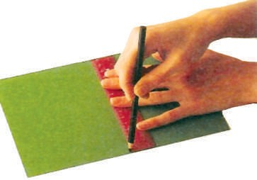
��G��CG� �É�É�dG
.(39) ��°�dG
.�ô£°�eh ¢�É°�Q º�b �
����«�ª©ædàGd�G �GG£�£�
1
.�GhOCGh �ÉeÉ�dG :(39) ��°�dG

34

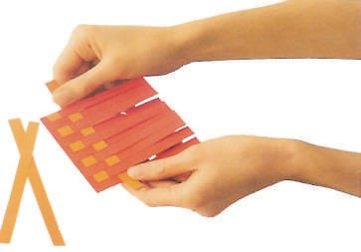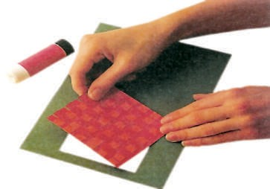
5
6

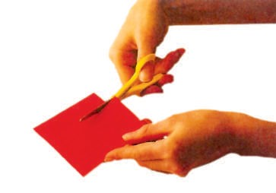
3
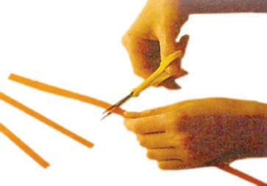
4

35


(2) �É°�f
?(40) ��°�dG »� ábÉ£�dG á�ô�� »� �ó��°�ªdG QGô��dG ´f Ée
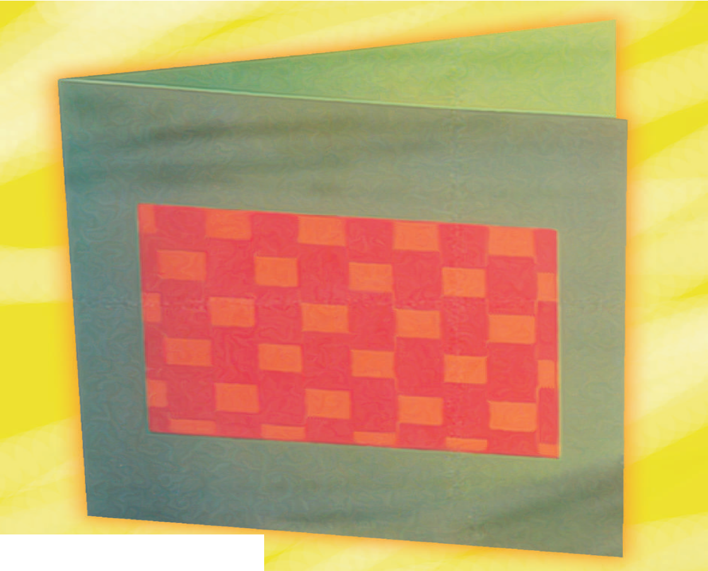

.ábÉ£��d »FÉ�ædG ��°�dG :(40) ��°�dG
36



�ó�dG ºj��
?ø���°�dG ø�H �ôØdG Ée
1
:�GôØdG »� É�����G/É����G º� .��°�dG �°SÉæj Ée �GQÉ��dG øe QÉ��G/ô��G (QGô��dÉH á�ô��dG - �OÉ��dÉH á�ô��dG)

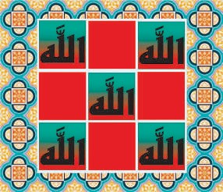

....................................................................... ...................................................................................................................

?�OÉ��dÉH hCG QGô��dÉH á�ô��dG �ó�É°T øjCGô��CG
2
.................................................................................................. .1
.................................................................................................. .2
.................................................................................................. .3
37

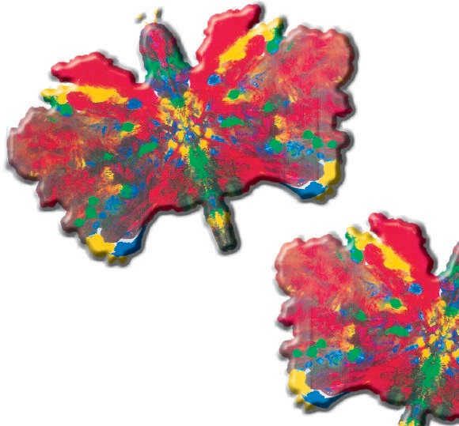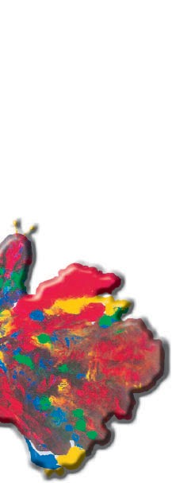
:�ó�dG �ÉY°Ve
.�É�°TCÉH �£�dG ™�WCG ���1
.¢�eÓe �G� � É�°TCG ™�WCG ���2

اﻟﻮﺣﺪة اﻟﺜﺎﻟﺜﺔ ﻣﺠﺎل اﻟﻄﺒﺎﻋﺔ

39


»ªbôdG ¢SQódG §HGQ
www�ien�edu�sa
�É�°�CÉH �£�dG � ÑWCG
��C G ´°VªdG

.á��ª� á�£� �G� É�d �ô�ã� �É�°TCG �Éæ�
.ô�ã� É�ô��h �YÓªdGh ,á����°SÓ�dG »HÉ�dCGh ,��ëdG �dÉ��
.(41) ��°�dG ,áYÉ�£dG �ÉªYCG »� �É�°TCG �ò� øe �OÉØ�°SG »ææ�ªj

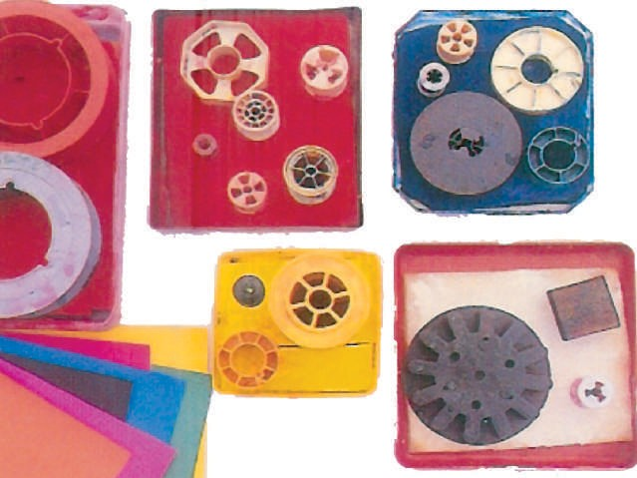
.á�£� �G� É�d �É�°TCG :(41) ��°�dG
?�ô�CG øY ����� �GëH á�£b �� ��ª�� ��� ��Óf
.É�H ™�£f �CG ójôf »�dG �GdCÉH É���°�f º� �á�°SÉæe �ë°� »� É°TÉªb ™°�f
.����e �d ��Y �ëj øë°� ��
40

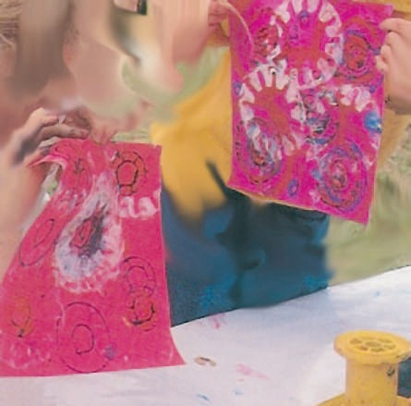
.ábQ�d »FÉ�ædG ��°�dG :(43) ��°�dG

.(43 ,42) �Ó�°�dG ,º°SôdG ábQh ��Y ���WCG º� ,��dG ��GO ��°�dÉH §�°VCG
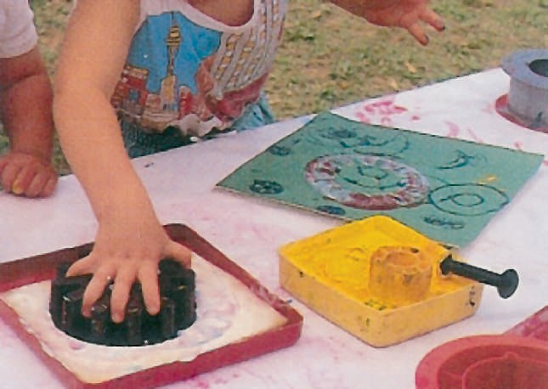.��°�h � �°�e í£°S ��Y ábQdG ��� �CG ��j
.ábQdG �ë� ��°� í£°S ��Y áYÉ�£dG :(42) ��°�dG

41

.(44) ��°�dG ,»°�HÓe �°���  ��� ���fCGh ÉeÉª� ���d É��ô�CG �É��fG ó�H
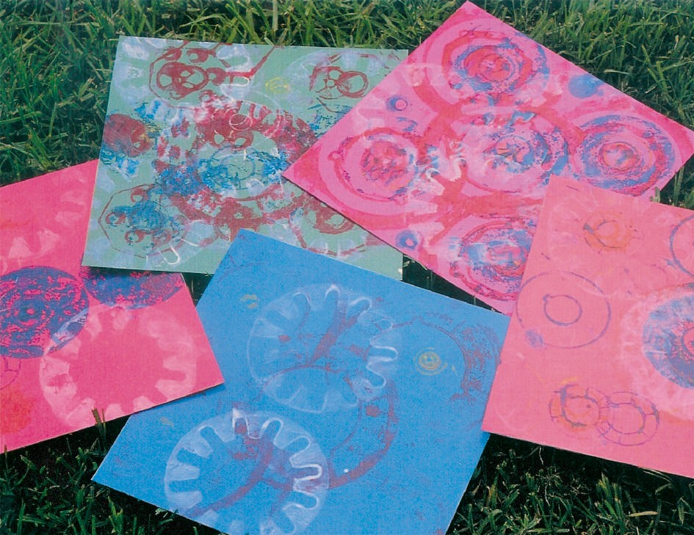
.��� ��� �GQhCG �ô�f :(44) ��°�dG
,��ÉæªdG �GQó� Gæj� ��d áØ���ªdG �É�°TCÉH áYÉ�£dG Geó��°SG É°�jCG ÉfOGó�CG
.(45) ��°�dG

.OGó�C G É��æ°� »�dG �GQó�dG ��Y áYÉ�£dG :(45) ��°�dG
42

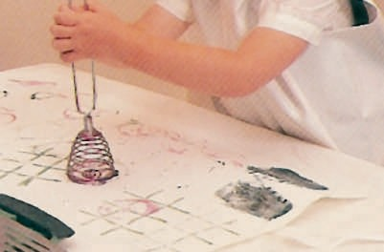


�É°�f

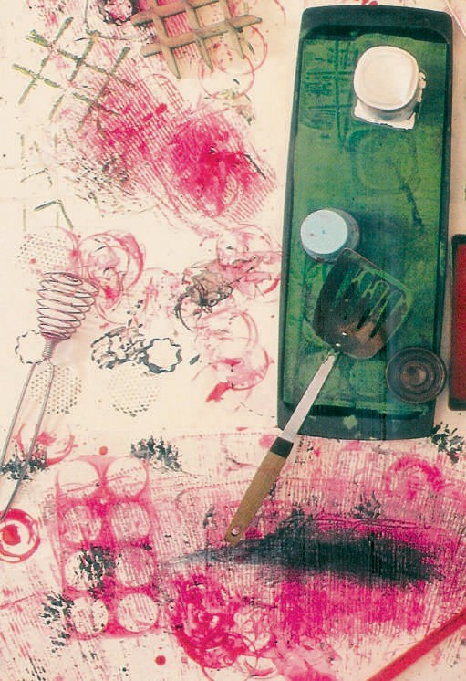OGô�CG ó�CG ™e �hÉ��dÉHh ��æªdG »�
.áYæ�ªdG �É�°TCÉH áYÉ�£dG :(46) ��°�dG
�Gó��°SÉH áHô��dG Qô��� ����ô��°��SCG
.(46) ��°�dG ,�ô�CG OGe

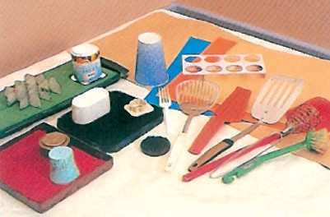

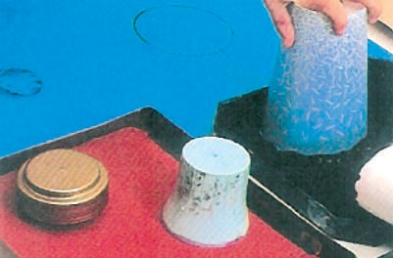
�°ü�CG »�dG �É�°TCGh �£�dG �ª�CG Ée
.áØ���ªdG �É�°TCG áYÉ�£H É���Y

43

.É�ª°Sôf �CG ™�£�°�f Éª� ,¢�eÓªdG ø�H ��ªf �CG ™�£�°�f ¢�ª�dG �Ó� øe
.á��ªeh á��°S á�jô£H ..áYæ�e ¢�eÓe ™�£f �CG ��G �hÉëf

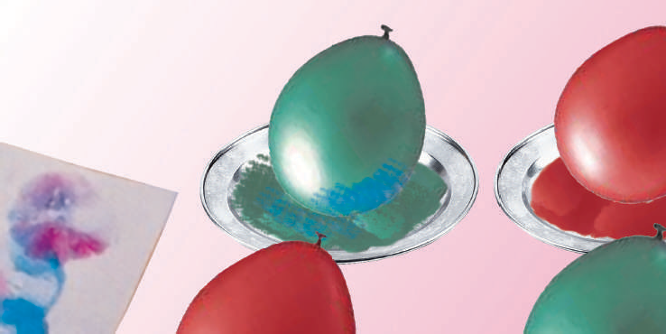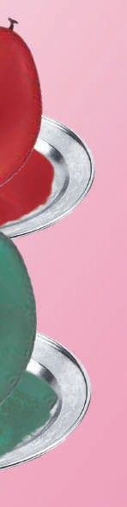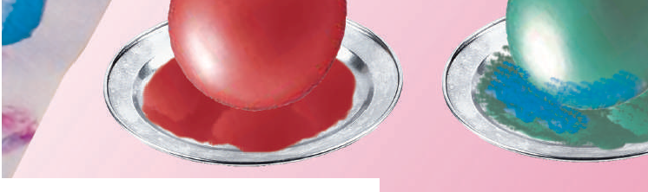
.�GdCG øe á�YhCG ��GO �ÉfdÉ�dG :(47) ��°�dG
.(47) ��°�dG ,�GdCÓd �ÉYh »� É�æe �G��CG ôª�f º� ,�ÉfdÉH ô°�ëf

��dG »� ôª�
ô°��
G �dÉ�dÉ� ,Gó
�Gh Éf� d �dÉH ��d �CG ��Óf �CG ��j

.ôª�
G ��dG »� ôª�
ôª�CG �dÉ�dGh ,¥QRCG


»ªbôdG ¢SQódG §HGQ
www�ien�edu�sa
¢ùeÓe äGP k É�°TCG o ÑWCG
»fÉãdG ´°VªdG

44

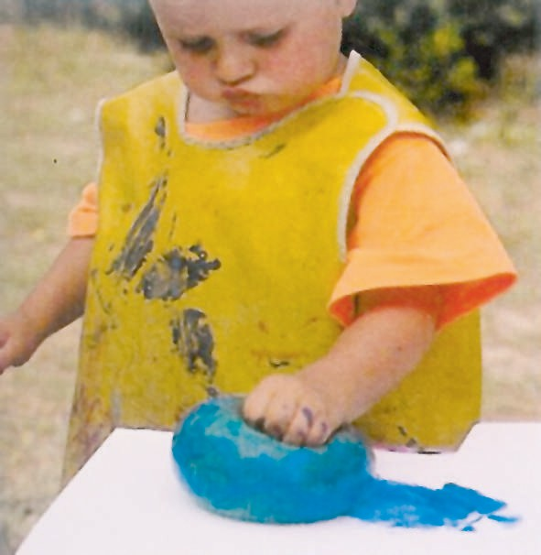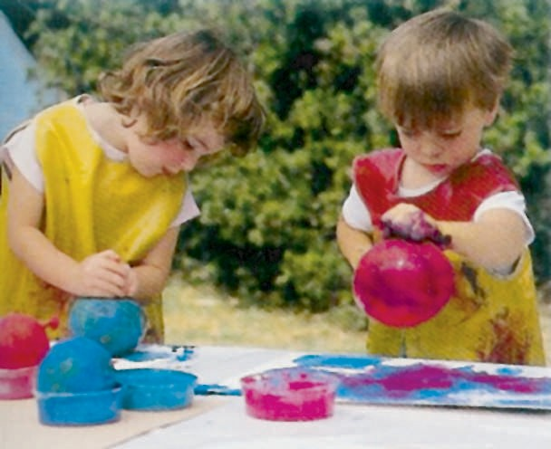
,�ÉfdÉ�dG ó�CÉH �°�ªf
�ÉYdG øe ���ôfh
��°�f º� ,»���°SÓ�dG
�É°��H ábQh ��Y
,��H ���Y §�°�fh
�É�e �dEG ���æf º�
���ª� ��� Gò��h ,ô��G
.(48) ��°�dG ,ábQdG
:(48) ��°�dG
.�dÉ�dÉH ™�£dG

™e �ô�°TCG �CG »fÉ�eEÉH
�ÉfdÉH �ó��°SCGh »FÓeR
,ôª�CÉ� áØ���e �GdCÉH
.(49) ��°�dG
.»FÓeR ™e ™�WCG :(49) ��°�dG

45

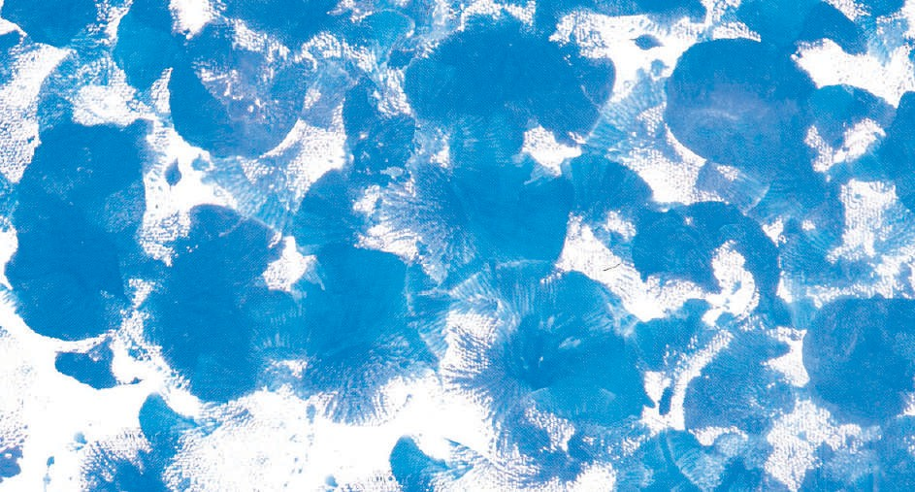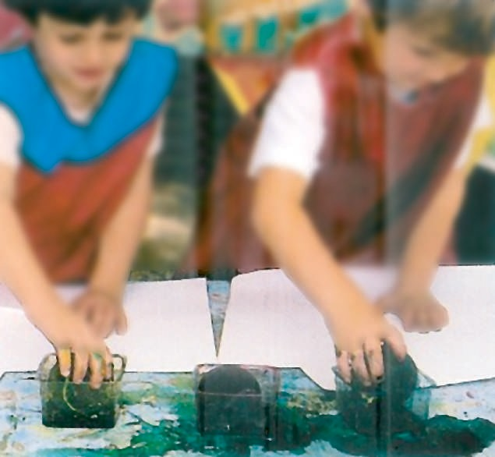
�ó��������°��SCG �CG »��æ��æ�����ª��j
»æ�£��d ¢�����æ�����dG �ô�����
.áØ���e �ô�CG ¢�eÓe
»� ¢�æ�dG �ô��� ¢�ª�f
»�����������°��SÓ�����dG �É����Y����dG
.(50) ��°�dG ,�GdCÓd
.¢�æ�dG �ô�H ™�£dG :(50) ��°�dG
.�É� �É�e »� ���d ábQdG �ô�CG �CG ��j

46

º� ,��YCG �dEG �ô�dG ™�ôf
,�É°���dG ábQdG ��Y É�£�°�f
.(51) ��°�dG

.¢�æ�dG �ô�H ™�£dG á�jôW :(51) ��°�dG

Qô�fh ,Gó
�Gh Éf� d �ô� ��d ���f
.¥QdG ��Y �ô�dG »eQ

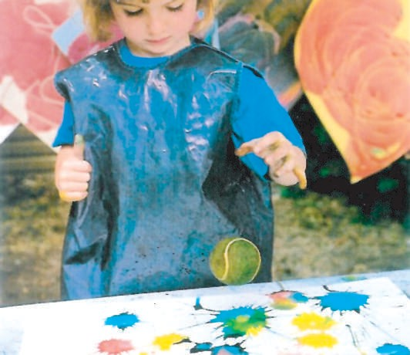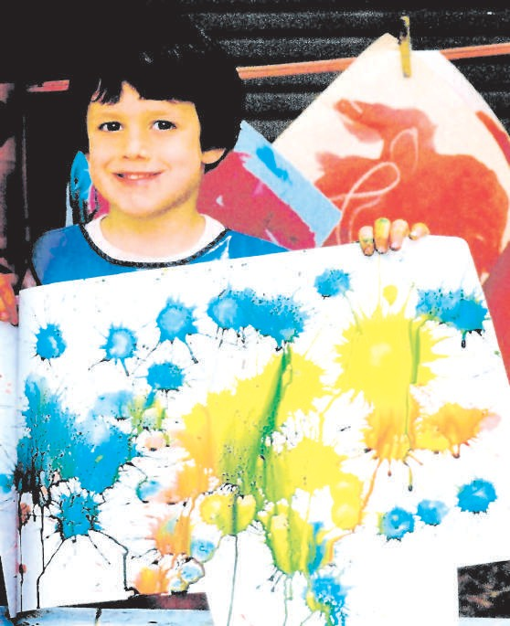,ájÉ�ædG »� �°üëæ°S G�Ée ô�fCG
.(52) ��°�dG

á�FÉ�ædG á���ædG :(52) ��°�dG
.¢�æ�dG �ô�H áYÉ�£�d
47


�É°�f
�G� �É�°TCG áYÉ�£d �ó��°�ªdG ô�� ¢TÉª�dG hCG ,�æØ°SEG øe É�£b �ó��°�f
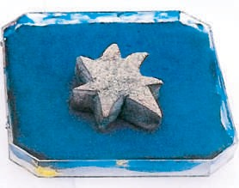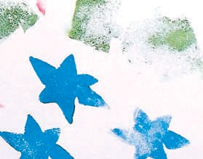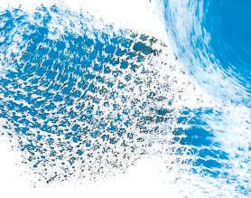.(53) ��°�dG ,áYæ�e ¢�eÓe
.áY�£e áYæ�e ¢�eÓe �É�°TCG :(53) ��°�dG
�RÉª�dG øe á��ÉædG ¢�eÓªdG ��Ófh ,ø�fd »� �dÉ�dG ¢�ª� Éææ�ªj Éª�
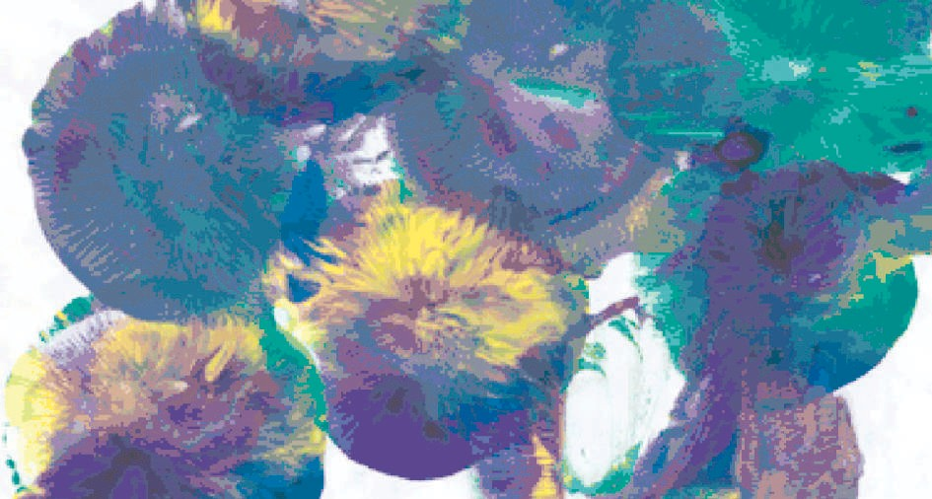.(54) ��°�dG ,»f�dG
.�d øe ôã�CG »� É�ôª� ™e �ÉfdÉ�dÉH áYÉ�£dG :(54) ��°�dG
48

�ó�dG ºj��

:áYÉ�£dG ´f �Q°� �� �ë� »���G/���G áYÉ�£dG �É�e »� ��ª��� Éªe 
.(¢�eÓªdÉH - �É�°TCÉH)
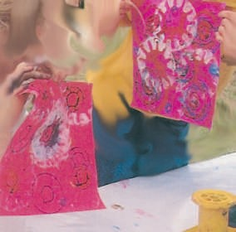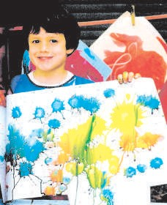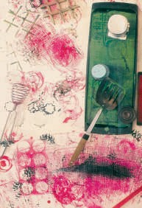

..............................................
..............................................
..............................................

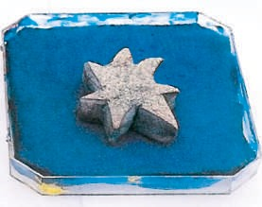

....................................................... ....................................................... .......................................................

49


:�ó�dG �ÉY°Ve
. OÓH øe ���1
.ó�Øe ø�£dG ���2
.ø�£dG øe � É�°TCG ™æ°�CG ���3
.�ó�Øe á�f�ô�dG ���dG ���4

اﻟﻮﺣﺪة اﻟﺮاﺑﻌﺔ:
ﻣﺠﺎل اﻟﺘﺸﻜﻴﻞ اﻟﻤﺴﻄﺢ واﻟﻤﺠﺴﻢ
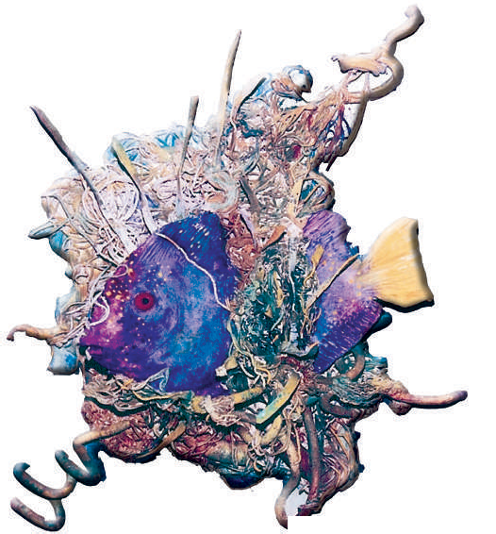

51


��ÓH �e
��CG ´°VªdG

»ªbôdG ¢SQódG §HGQ

www.ien.edu.sa

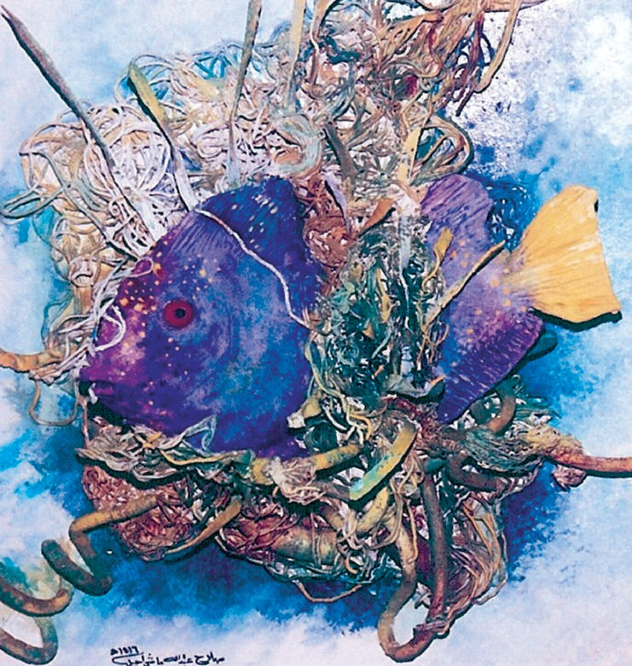
.�ó� áæjóe øe ���Gô°TÉH �Ó°� �ÉæØ�d á�d :(55) ��°�dG
!(55) ��°�dG , OÓH øe �ÉæØd á��dG �ò� á��ª� »� º�
.»�É�d »� øFÉ��dG �ó��°SCGh ÉfÉæ� í�°�CG �CG �æª�CG
.»dÉªYCG »� �É°ü�°üdG áæ��Y �Gó��°SG »ææ�ªj

52

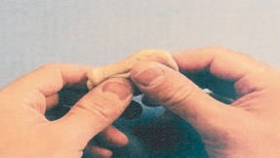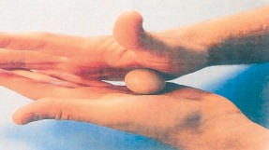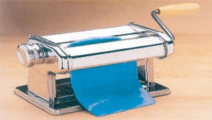
,��f�d ��Y �ô��æd Éæ�HÉ°�CÉH �É°ü�°üdG ø��f
.(57) ��°�dG
.Éæ�HÉ°�CÉH �É°ü�°üdG áæ��Y ���°�� :(57) ��°�dG
,Éæ�Ø� � ø�H �É°ü�°üdG ôjhó�H �É°ü�°üdG øe É�� Gô� ™æ°üf
.(58) ��°�dG
.�É°ü�°üdG øe �Gô� ™æ°� :(58) ��°�dG
,�É°ü�°ü�d øFÉ��dG OôØH á°�É� ��G �eó��°�j QÉ��dG
.(59) ��°�dG ,íFGô°T ��Y �°üëdGh
.QÉ��dÉH á°�É� áæ���dG ���°��d �G� :(59 ��°�dG

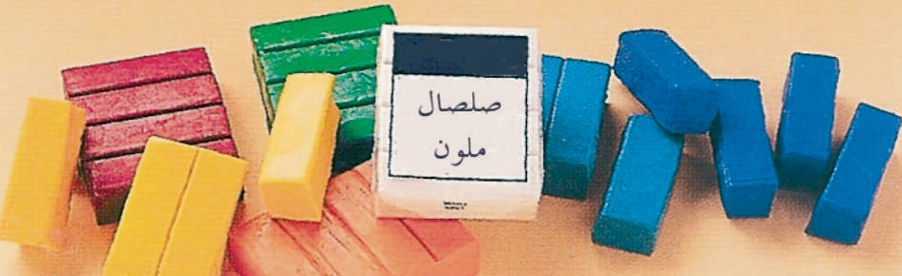.(56) ��°�dG ,áf��dÉH RÉ�ª�h ,á��GR �GdCG É�d �É°ü�°üdG áæ��Y
.�É°ü�°üdG áæ��Y :(56) ��°�dG
�É°ü�°üdG áæ��Y ���°�� ¥ôW

53

.Gó�� ø°��dG í£°�dG ��Y �°ü��� �É°ü�°üdG áæ��Y
.(60) ��°�dG ,á��ª� á�d �æe ™æ°�CGh ø°��dG �ôØæ°üdG ¥Qh ô°��CÉ°S
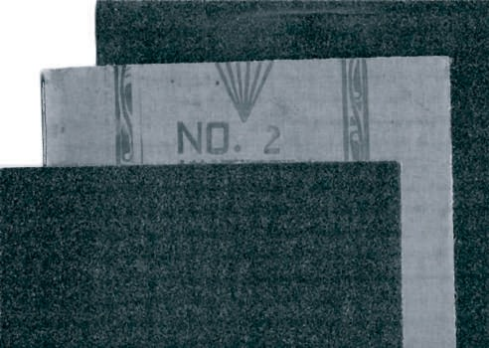
.�ôØæ°üdG ¥Qh :(60) ��°�dG

�Gó��°SÉH �ôØæ°üdG ¥Qh ��Y ��ª�°�SQCGh ,á��ª�dG OÓ��H ø�e Gô�æe QÉ��CÉ°S
�ª�H ÉeEGh OôØdÉH ÉeEG ,¥QdG ��Y �É°ü�°üdG �°ü�H �bCG º� ,á��ª°�dG �G�dCG
.áYæ�e �GdCÉHh �É�É°�ªdG É�H CÓeCG ,�ô��°� �Éjô�
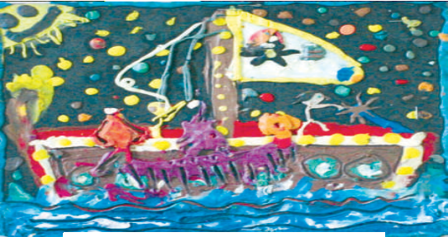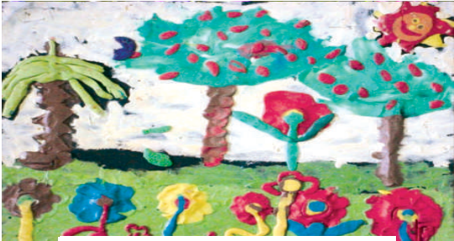.(62 ,61) �Ó�°�dG ,�É°ü�°üdG �ÉªYCG á��ª� »� º� Ghô�fG

.�É°ü�°üdG øe �ÉªYCG :(61) ��°�dG
.�É°ü�°üdG øe �ÉªYCG :(62) ��°�dG

54

,��ædG ´hò�d �eó��°SG »�dG áª���°�ªdGh á�æëæªdG �£�dG �ª�CG Ée
.(63) ��°�dG
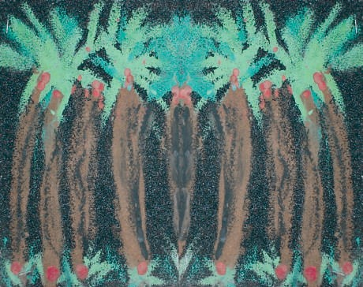
.���ædG ´hò� :(63) ��°�dG

. OÓH øe á�d ��� �� �ªdG �É°ü�°üdÉH �ôØæ°üdG ¥Qh ��Y ���°��dG �ô�CÉ°S
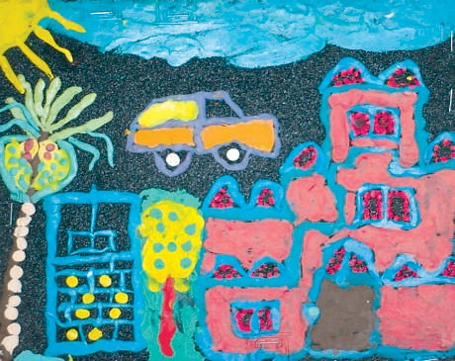
.á��ª�dG »�æjóe :(64) ��°�dG
?áf«�dÉH �ÉàªJ »àdG �É«°TCG �e ±ô©J GPÉe ��G�°S

55


ó«Øe ø«£dG
»fÉãdG ´°VªdG

»ªbôdG ¢SQódG §HGQ

www.ien.edu.sa

�ÉfG�ëdG øe ��ªë�d �d �hCÉeh Éæ� �°S �GQÉ�ªdGh ���dG »FGó�dG �É°�fEG ò��G
.(65) ��°�dG ,á°Sô�ØªdG
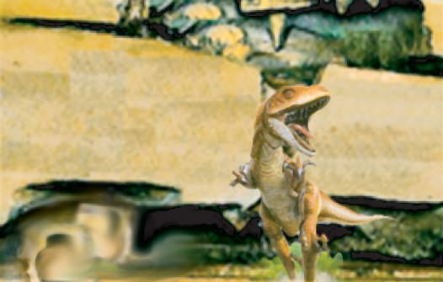

.á�FGó�dG Q°ü�dG »� á°Sô�ØªdG �ÉfG�ëdG :(65) ��°�dG

?�QÉ�ªdG »� Ée� ����dG � Ée
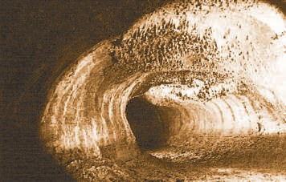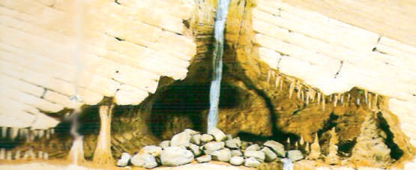.(66) ��°�dG ,�É��dG ��GO ���� (�Éë��) �ÉØj�� ���dGh �GQÉ¨ªdG
IQÉ¨e
.�QÉ�ªdGh ���dG :(66) ��°�dG
���

56

?���dG� �QÉ�ªdG ø«H �ôØdG Ée
.Iô�¨°� IQÉ¨ªdG á�É°�e .Iô��� ���dG á�É°�e

(1) �É°�f

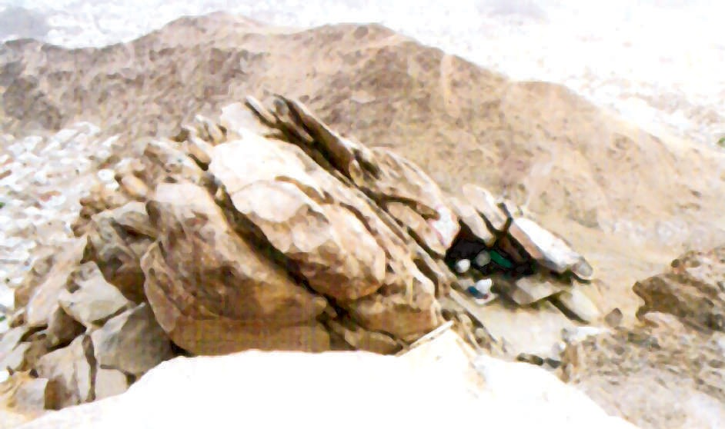.˜ óªëe �°SôdG ��Y »�dG ��� ��f QÉ� ÉæeÉeCG »�dG IQ°üdG »�
.�Gô� QÉ� :(67) ��°�dG
?™�j áæjóe CG »�h ,��� ó�j òdG ���dG º°SG Éeh ,QÉ¨dG º°SG � Ée
.(67) ��°�dG

57

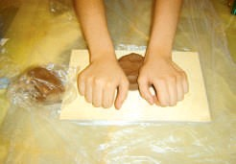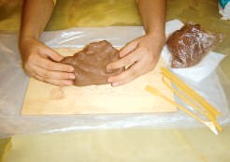
.���°���d É������d áæ�£dG ø��f
2
��������°���SCÉ���H á���æ�������£���dG ��������°�������f
.á��� »� §¨°�dG
3

.(68) ��°�dG :á�dÉ�dG �ÉeÉ�dG �dEG IQÉ¨e hCG ,��� ���°�� óæY �É�ëf
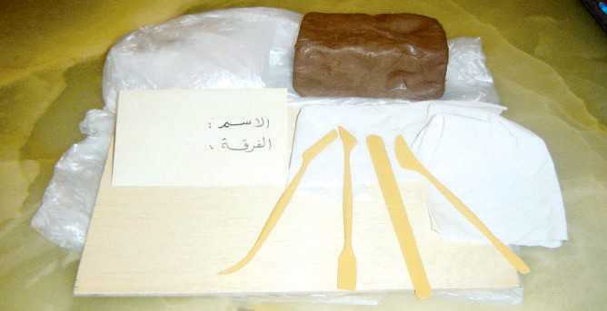
.IQÉ¨ªdG hCG ���dG ���°��d �ÉeÉ� :(68) ��°�dG
�ª©dG äG£�

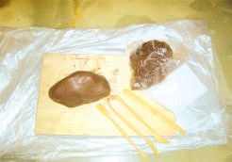
���°�� »� ¢�É�dG ÉæH�°SCGh Éæ�GQÉ�e Rô�fh ,á�dÉ�dG �ª�dG �G£�H ó°Tô�°�f
.IQÉ¨ªdG
.áæ�£dG øe É�� °SÉæe GQób ò�CÉf 1

58

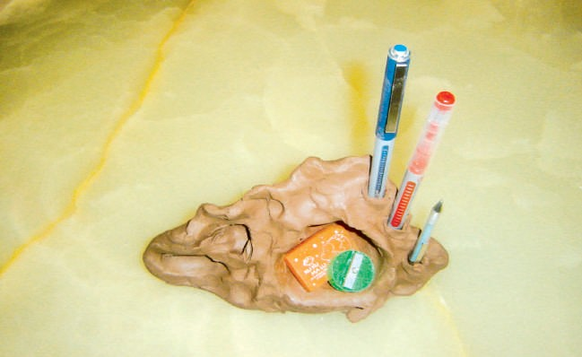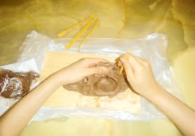
.�ÓbCG ™°Vd �É°ü�°üdG øe �ªY :(69) ��°�dG
º��FÓ��j É��ª��H �É��ë������ �ó���ë���f
.����dG Iô��
6
�«�àdG �ô�a

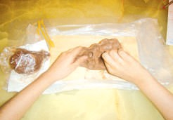
™HÉ°�CG �Gó��°SÉH ÉØj�� �óëf
.ó�dG
4
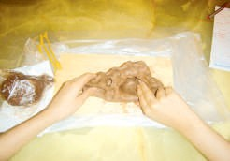
.É�����h IQÉ¨ªdG ��°T Oóëf
5

59

?Ió�Øe »� �� ?(69) ��°�dG ,Iô�ØdG �ò� »� ÉjCGQ ó�æd
?�ó�É°�f òdG �ª��d �ô�CG GQÉ��CG �ô��f ��

.É��� ÉædÉªYCG ���� ø�ªj »�dG Ió�ØªdG QÉ��CG ¢��H Oó
�æd
�«�àdG �ô�a

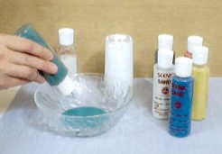

.��ªY �ÉYh »� �� �ªdG �eôdG ™°�f


(2) �É°�f
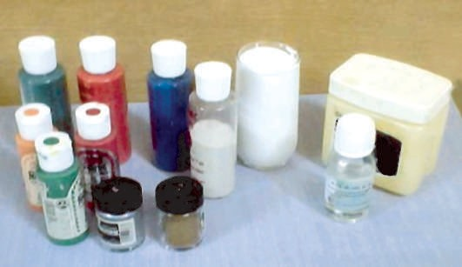.(70) ��°�dG ,���°��dG »� ��ªdG �eôdG �Gó��°SG �ô�æd

60

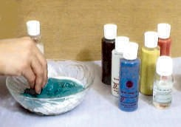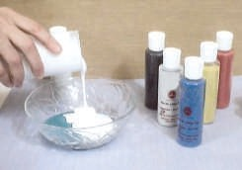
(¢�����HCG �Gô��¨��dG) �°��dG �Gô���� ��°�f
.�eô�d
áæ��Y ���� ��� �Gô¨dG ™e �eôdG ��ªf
.á�°SÉª�e
.�� �ªdG �eôdÉH ���°��dG �G£� :(70) ��°�dG

�á��Óe

�GdCG ��°�fh ,OGóYEG á�jôW ¢�ØæHh »���£dG �eôdG øe IOÉØ�°SG Éææ�ªj
.Éæjód Iô��ªdG

61


ø«£dG øe k É�°TCG æ°UCG
ådÉãdG ´°VªdG

»ªbôdG ¢SQódG §HGQ

www.ien.edu.sa

,�dÉ�dG á��� Éæ�£��d áæ�£dG ���°�� »� áë£°�ªdG ™£�dG �dGb �Gó��°SG
.(71) ��°�dG ,áYæ�e �É�°TCG É�dh
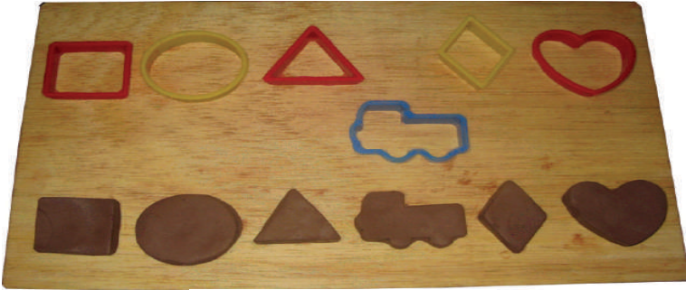
.�dG�dG �É�°TCG :(71) ��°�dG

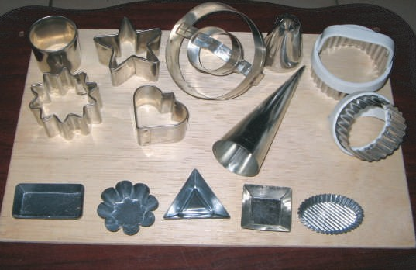,���dG�����dG É��æ��jó��d ô��������j º���d G�EG ó�j ��æªdG »Ø� ,(72) ��°�dG Éææ�ªj ô��°���É��æ�����dG ø���e ó��jó�����dG á��������ª��Y »����� É�������æ���e IOÉ����Ø���������°����SG
.���°��dG »� ��ëdG �dGb �Gó��°SG �ô�æd :(72) ��°�dG
.���°��dG

62

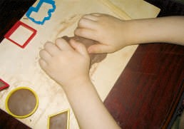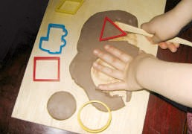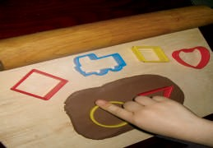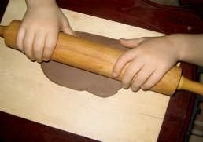
áæ�£dG øe ¢�FÉØdG ™ª�G
.�æe IOÉØ�°SÓd �æ�YGh
4
.�dÉ�dG øY áæ�£dG �RCG
3
.áæ�£dG ��Y �dÉ�dG §¨°VG
2
.�dÉ�dÉH ���°��dG »�
.áæ�£dG Oô�G
1

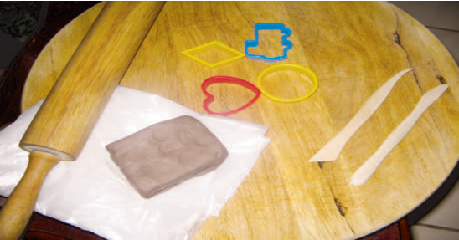É��É�ëf »�dG �GhOCGh �ÉeÉ�dG
.�GhOCGh �ÉeÉ�dG :(73) ��°�dG
.(73) ��°�dG ,�dÉ�dÉH ���°���d


����«Øª©ædàGdäG äGG£�£�
Éæ�QÉ�e Rô�fh �ª�dG �G£� ™HÉ�f

63

IòØæªdG �É�°TCG ��Y É�Ø�°�f �CG ø�ªj »�dG �Gô��CÉ�dG øe OóY ôã�CÉH ô�Øæd
.Éª� ôã�CG ���d

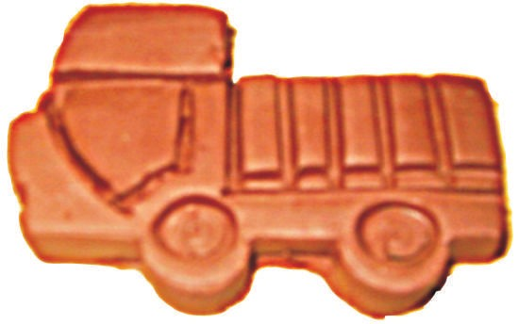

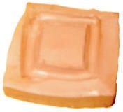
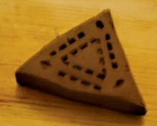
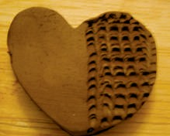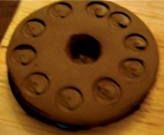

.IòØæªdG �É�°TCG øY á��Éf �Gô��CÉ� :(74) ��°�dG
.(74) ��°�dG ,�Gô��CÉ�dG �ò� »� ÉjCGQ ó�æd
?�É�°TCÓd Éª� �£YCG ��
?�Gô�É� §�dGh á£�ædG Gô°üæY ��
?�Gô��CÉ�dG �ò� �ª�d �eó��°SG É�fCG ™b�f »�dG �GhOCG Ée

64

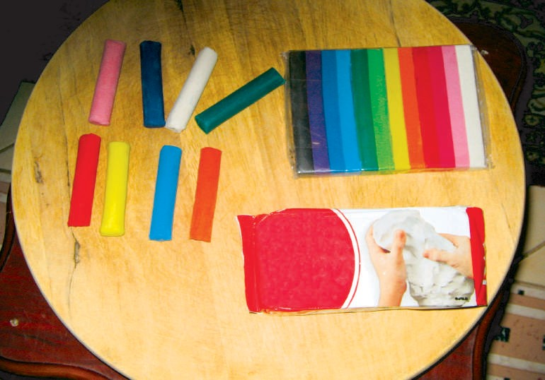
.á�YÉæ°üdG �Éæ�£dG ¢��H ´GfCG :(75) ��°�dG


�«�àdG �ô�a
?É�ó�É°�f »�dG ��Éªæ�d �ô�CG �Gô��CÉ� �ô��f �CG ø�ªj ��

Éæªb »�dG ��ÉªædG É��� ��f �CG ø�ªj »�dG Ió�ØªdG QÉ��CG ¢��H Oó�f
.É����°��H

(1) �É°�f

.(75) ��°�dG ,���°��dG »� á�YÉæ°üdG �Éæ�£dG ¢��H �Gó��°SG �ô�æd

65

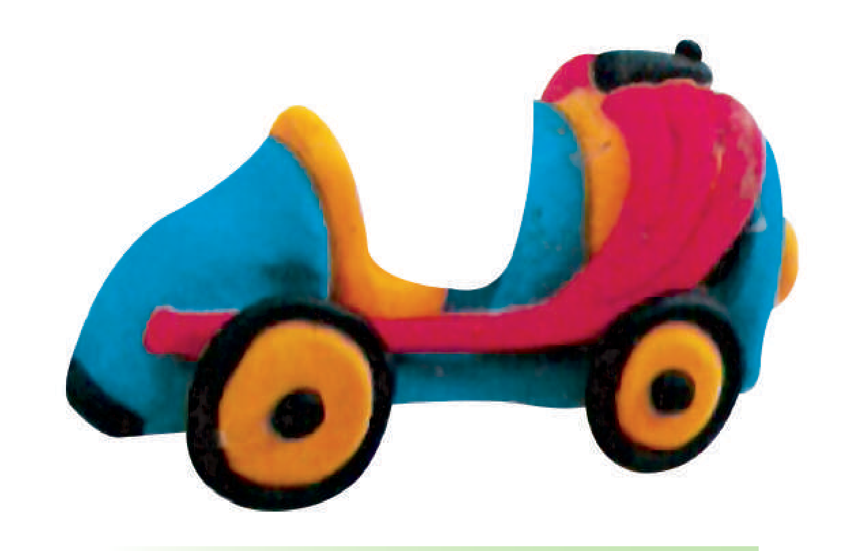.��G��e º�CG ô�òf ,���°��dG »� ��ªdG »YÉæ°üdG �É°ü�°üdG �jô��H ÉæeÉ�b ó�H
.���°��dG »� ��ªdG »YÉæ°üdG �É°ü�°üdG :(76) ��°�dG
(2) �É°�f

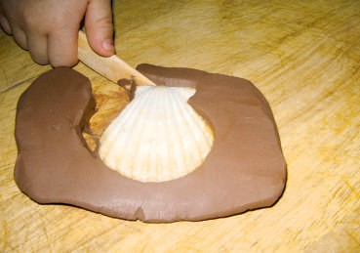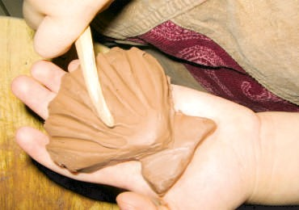
.�É°ü�°üdÉH �É�°TCG áYÉæ°� :(77) ��°�dG
?(77) ��°�dG »� ø��Q°ü�d Éæ�ó�É°�e óæY ÉæfÉ��CG »� �ô��CG »�dG QÉ��CG Ée
.QÉ��CG �ò� ÉæFÓeR ™e ¢�bÉææd

66


�ó«Øe á«fJô�dG ��©dG
HGôdG ´°VªdG
www.ien.edu.sa
»ªbôdG ¢SQódG §HGQ

.á�æØdG ÉædÉªYC Ió�Øe á�QÉØdG á�f�ô�dG ���dG
.ªædGh ���dGh Iô�GòªdG ��Y ÉfóYÉ°�jh Éæj�j �Gò� ø��dGh ���ëdG
.(78) ��°�dG ,Éæ�æjóe á�É�f »� º�É°�fh É�æe ó�Ø�°�f ,É��eôf  á�QÉØdG ���dG

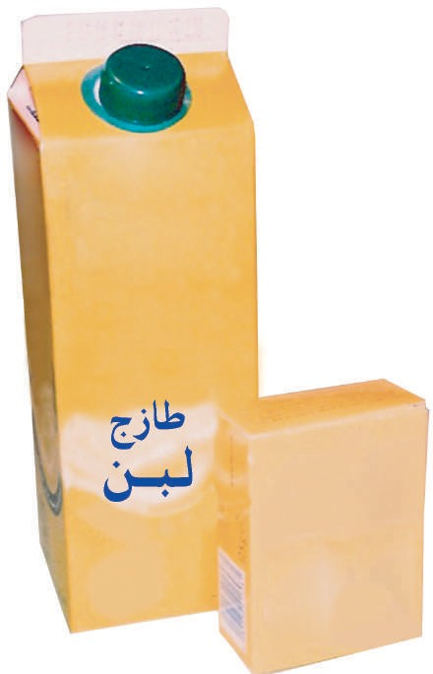?á«æa �ÉªYCG »a á�QÉØdG ��©dG ��� øe ó«Øà°ùf �«c �ôJ
.á�QÉ� ��Y :(78) ��°�dG
67

.(80 ,79) �Ó�°�dG :�dEG Éæ�ªY »� �É�ëf
.¥Q�d �ª°��

.�ÉØ°T �°��
.á�f�ô� ��Y�

.ójóë� �ÓbCG�
.�� �e ¥Qh�

.��ª°S ��ô� ¥Qh�
.¥Qh ¢ü�e�
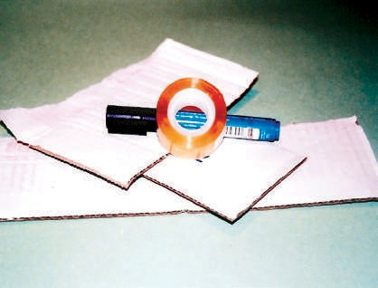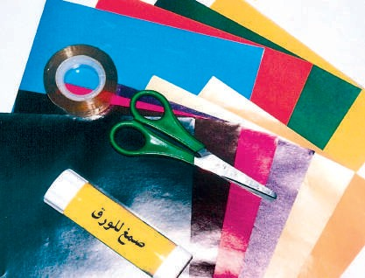

IQÉ�°S ™æ°üd �GhOCG :(80) ��°�dG
.��ô�dG ��Y �Gó��°SÉH

IQÉ�°S ™æ°üd �GhOCG :(79) ��°�dG
.áf�ªdG ��ô�dG ��Y �Gó��°SÉH

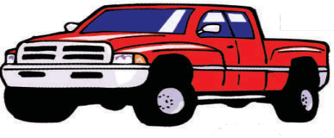.á��ª� IQÉ�°S á�QÉØdG á�f�ô�dG ���dÉH ™æ°üæ°S
:É��ô�f �É�°TCG øY IQÉ�Y IQÉ�°�dG

. ôFGódG ��°�dG
.™HôªdG ��°�dG
.��£�°�ªdG ��°�dG

68

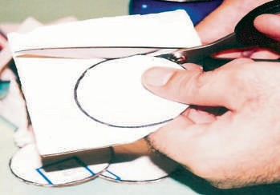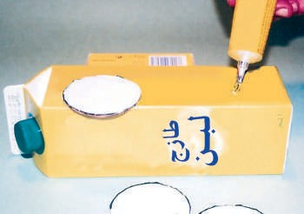
.IOÉ� ád�G ¢ü�ªdG �
C �QòëH ôFGhódG ¢ü�f
2
3
.á�f�ô�dG ���dG ��Y É���� ãf º�
.IQÉ�°�dG �Ó�Y ��°�� ôFGhódG �ë�°�CG ��G

á�«£à°ùªdG� á�ô�GódG� á©HôªdG �É�°TCG ó�É°�f ø�CG G�ô�a
�«�àdG �ô�a
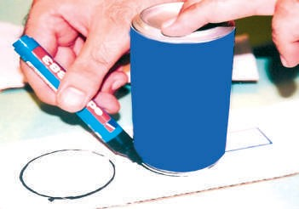?ÉæJÉ«� »a
��ª©dG CGóÑæd
1
ôFGO º°�� CG �Gó��°SÉH ôFGhO ™HQCG º°Sôf
.ô�°ü�dG ����

69

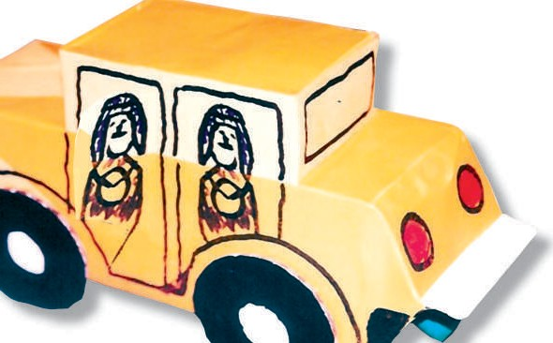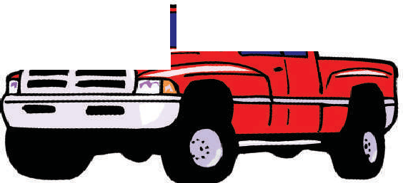
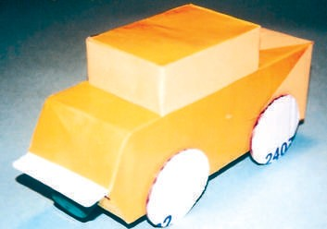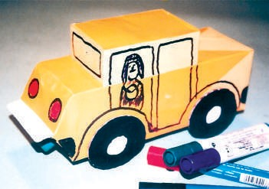
4
�É�� ™�ª� ��Y �� �ªdG ¥QdG �°ü�H ��f
.�Ó��dG GóYÉe ��ô�dG
5
º� ,O°SCG ójóë�dG º��H �Ó��dG �� �f
.IQÉ�°�dG ��°�ÉØ� º°Sôf

70

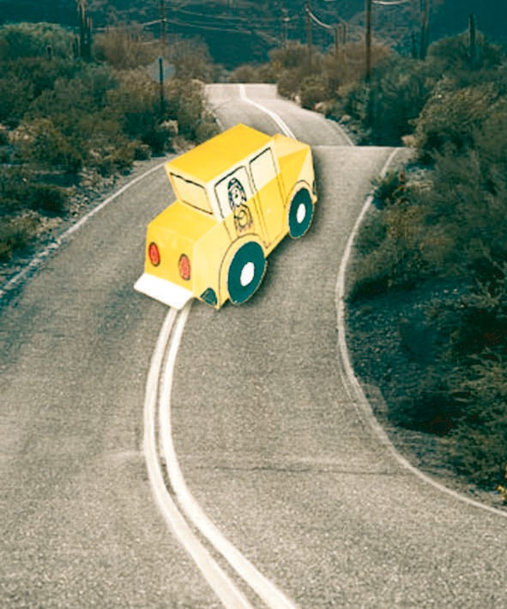É�H ���f ájO�°S �GQÉ�°S ™æ°üæ°S ô��f ÉeóæY ,á��ª� »� º� ,Éæ�QÉ�°S �dEG Ghô�fG
.á��ª�dG Éæ�QÉ�°S :(81) ��°�dG
.(81) ��°�dG ,á���ëdG ÉfOÓH »�
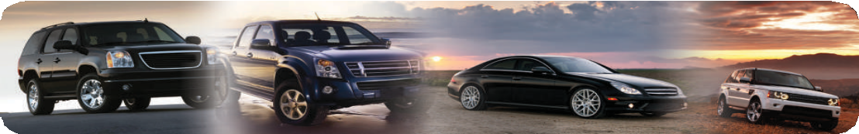
71


�É°�f

.É°�
jCG Éª
�� ô��CG ��ô�dG øe IOÉØ�°SG Éææ�ªj

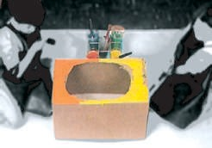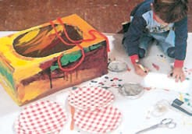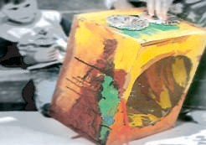
:ô��CG IQÉ�°S ™æ°�CG ��æªdG »� QÉ��dG IóYÉ°�ªH
1
.��ô�dG �� �f
2
.á�bQdG �ë°üdG ��Y º°Sôf
3
.��ô�dG ��Y ��ª°�dG §��dGh �ë°üdG ��� ãf

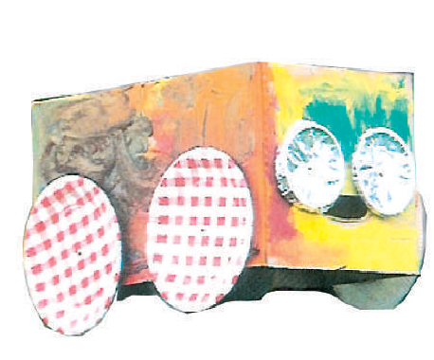,�G����dCGh ,ô������ �QÉ���� ����ô�����d §���� �É���ë�f
.��ô�dG øe »�QÉ�°S :(82) ��°�dG
�H ���������f ����ª�°�S §������h ,á�������bQh ���ë��°���h Éæ�QÉ�°S �ò���� .¢��������� ô�����eÉ��°�����eh ,IQÉ�����°�����dG
.(82) ��°�dG ,á�jô°�dG

72



Ió�dG ºj��
:á�dÉ�dG Q°üdG »� ø�£dÉH ���°��dG �G£� »��� Q/��� Q
1
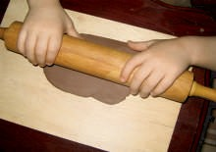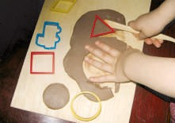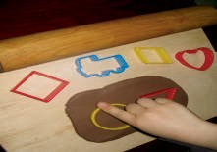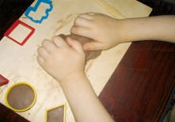
( ) ( ) ( ) ( )

.(IQÉ¨e - ���) É��°SÉæj Ée IQ°� �� �ë� »���G/���G
2
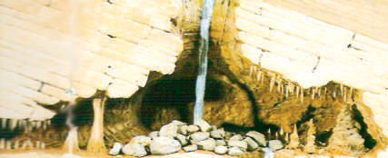
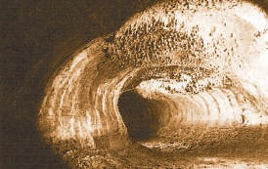

............................................................... ...............................................................

.(5-1) ��ô�dÉH IQÉ�°�dG ™æ°� �G£�d ÉªbQ »�°V/™°V
3
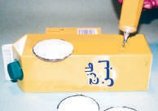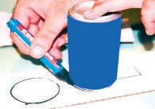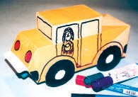
( ) ( ) ( )
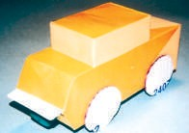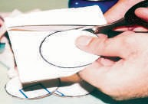
( ) ( )
73

اﻟﻤﻼﺣﻖ:
�Q°üdG� �É�°TCG ¢Sô�a �

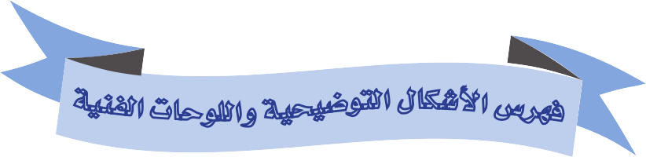��d� G �ó�dG
S
�d
�
»fÉãdG »°SGQódG �°üØdG

áëØ°üdG ��°�dG

- .º°Sôj óªëe (1) ��°�dG
11 .§� »� �É�ædG ™ª�� (2) ��°�dG
- .óªëªd �óë�j §�dG (3) ��°�dG
12 .á�WÉ��e �£� Ió�d º°SQ (4) ��°�dG
13 .�£�dG øY ���f »�dG �É�°TCG (5) ��°�dG
14 .áªYÉf í£°SCG (6) ��°�dG
14 .áæ°�� í£°SCG (7) ��°�dG
14 .á�FÉ°T í£°SCG (8) ��°�dG
15 .¢�ª�ªdG øY ô�����d á�fd á�d (9) ��°�dG
15 .¢�ª�ªdG øY ô�����d á�fd á�d (10) ��°�dG
15 .¢�ª�ªdG øY ô�����d á�fd á�d (11) ��°�dG
16 .IRQÉ�dG í£°SCG ��Y º°SôdÉH ¢�eÓªdG (12) ��°�dG
16 .á��ª°�dG �GdCÉH ¢�ª�e (13) ��°�dG
17 .á��ª°�dG �GdCG ��Y á��ÉëªdG (14) ��°�dG
17 .¢�eÓªdÉH á��ª�dG »��d (15) ��°�dG

77

áëØ°üdG
��°�dG
18
18
18
20
20
21
22
23
24
24
25
.¢ShhÉW (16) ��°�dG
.§b (17) ��°�dG
.òØæb (18) ��°�dG
.™�°�EG áª°üH (19) ��°�dG
.áª°ü�dÉH º°SôdG (20) ��°�dG
.á��ª�dG ábGó°üdG (21) ��°�dG
.Iò�ÉædG ô�Y á°��óH ô�æ� á�ØW (22) ��°�dG
.ô£ªdG ¢Sb (23) ��°�dG
.ô£ªdG ¢Sb �GdCG (24) ��°�dG
.ô£ªdG ¢Sb º°SQCG (25) ��°�dG
.�É��dÉH øj��dG (26) ��°�dG

78


�á«fÉãdG �ó�dG

áëØ°üdG ��°�dG

28 .á�ª°S (27) ��°�dG
28 .ôªf (28) ��°�dG
28 .á�æ�dG ™��dG ó�� ôªf (29) ��°�dG
29 .QGô��dÉH á�ô��dG É��� ô��j á°�ªbCG (30) ��°�dG
29 .QGô��dÉH á�ô��dG É��� ô��j ¢SÉ��CG (31) ��°�dG
30 .�É�HôªdÉH QGô��dG (32) ��°�dG
30 .á�æ�°� »� »�ô�R QGô�� (33) ��°�dG
31 .��ªdG ¥QdÉH »YGô°T ��ôe (34) ��°�dG
32 .���¨�dG ¥GQhCG »� á�ô��dG (35) ��°�dG
32 .»f�dG �OÉ��dÉH á�ô��dG (36) ��°�dG
33 .�OÉ��dÉH �É�HôªdG QGô�� (37) ��°�dG
- .�QÉ�R øe �H Éeh á�ô°�ªdG á���dG �ÉH (38) ��°�dG
- .�GhOCGh �ÉeÉ�dG (39) ��°�dG
36 .ábÉ£��d »FÉ�ædG ��°�dG (40) ��°�dG

79

�áãdÉãdG �ó�dG
Ñ
É
áëØ°üdG ��°�dG

40 .á�£� �G� É�d �É�°TCG (41) ��°�dG
41 .ábQdG �ë� ��°� í£°S ��Y áYÉ�£dG (42) ��°�dG
41 .ábQ�d »FÉ�ædG ��°�dG (43) ��°�dG
42 .��� ��� ¥GQhCG �ô�f (44) ��°�dG
42 .OGó�CG É��æ°� »�dG �GQó�dG ��Y áYÉ�£dG (45) ��°�dG
- .áYæ�ªdG �É�°TCÉH áYÉ�£dG (46) ��°�dG
- .�GdCG øe á�YhCG ��GO �ÉfdÉ�dG (47) ��°�dG
45 .�dÉ�dÉH ™�£dG (48) ��°�dG
45 .»FÓeR ™e ™�WCG (49) ��°�dG
46 .¢�æ�dG Iô�H ™�£dG (50) ��°�dG
47 .¢�æ�dG Iô�H ™�£dG á�jôW (51) ��°�dG
- .¢�æ�dG Iô�H áYÉ�£�d á�FÉ�ædG á���ædG (52) ��°�dG
48 .áY�£e áYæ�e ¢�eÓe �É�°TCG (53) ��°�dG
- .�d øe ôã�CG »� É�ôª� ™e �ÉfdÉ�dÉH áYÉ�£dG (54) ��°�dG

80

�á©HGôdG �ó�dG
°

áëØ°üdG ��°�dG

52 .Ió� áæjóe øe ���Gô°TÉH �Ó°� �ÉæØ�d á�d (55) ��°�dG
53 .�É°ü�°üdG áæ��Y (56) ��°�dG
53 .Éæ�HÉ°�CÉH �É°ü�°üdG áæ��Y ���°�� (57) ��°�dG
53 .�É°ü�°üdG øe �Gô� ™æ°� (58) ��°�dG
53 .QÉ��dÉH á°�É� áæ���dG ���°��d ��G (59) ��°�dG
54 .IôØæ°üdG ¥Qh (60) ��°�dG
54 .�É°ü�°üdG øe �ÉªYCG (61) ��°�dG
54 .�É°ü�°üdG øe �ÉªYCG (62) ��°�dG
55 .���ædG ´hò� (63) ��°�dG
55 .á��ª�dG »�æjóe (64) ��°�dG
56 .á�FGó�dG Q°ü�dG »� á°Sô�ØªdG �ÉfG�ëdG (65) ��°�dG
56 .IQÉ¨ªdGh ���dG (66) ��°�dG
57 .�Gô� QÉ� (67) ��°�dG
58 .IQÉ¨ªdG hCG ���dG ���°��d �ÉeÉ� (68) ��°�dG
59 .�ÓbCG ™°Vd �É°ü�°üdG øe �ªY (69) ��°�dG
61 .��ªdG �eôdÉH ���°��dG �G£� (70) ��°�dG

81

áëØ°üdG
��°�dG
62
62
63
64
65
66
66
67
68
68
71
72
.�dG�dG �É�°TCG (71) ��°�dG
.���°��dG »� ��ëdG �dGb �Gó��°SG �ô�æd (72) ��°�dG
.�GhOCGh �ÉeÉ�dG (73) ��°�dG
.IòØæªdG �É�°TCG øY á��Éf �Gô��CÉ� (74) ��°�dG
.á�YÉæ°üdG �Éæ�£dG ¢��H ´GfCG (75) ��°�dG
.���°��dG »� ��ªdG »YÉæ°üdG �É°ü�°üdG (76) ��°�dG
.�É°ü�°üdÉH �É�°TCG áYÉæ°� (77) ��°�dG
.á�QÉ� ��Y (78) ��°�dG
.áf�ªdG ��ô�dG ��Y �Gó��°SÉH IQÉ�°S ™æ°üd �GhOCG (79) ��°�dG
.��ô�dG ��Y �Gó��°SÉH IQÉ�°S ™æ°üd �GhOCG (80) ��°�dG
.á��ª�dG Éæ�QÉ�°S (81) ��°�dG
.��ô�dG øe »�QÉ�°S (82) ��°�dG

82

