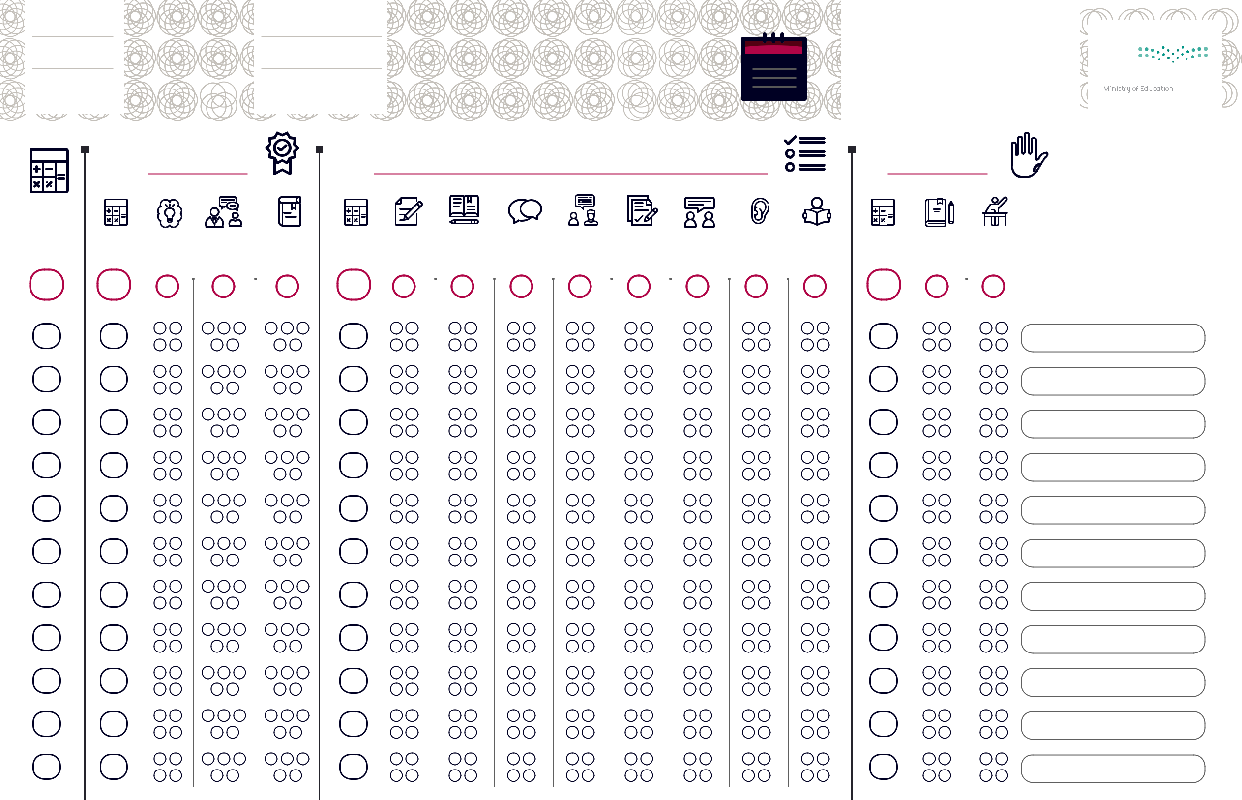
 |  |  |  | ﻢﻳﻮﻘﺗ ﺔﻗﺎﻄﺑ
 |  |  |  | ةﺪﻟﺎﺨﻟا ﻲﺘﻐﻟ
 |  |  |  | ﺔﻄﺳﻮﺘﻤﻟا ﺔﻠﺣﺮﻤﻟا
14 | 30 |  |  | 6
„‹ Œ • Œ •-  -Œ• Ž ‘

-Œ•- Œ Ž ‹

-Œ• ’••

“ •

ˆ
-• | ˆ | ‰• Š | †‡ • | ‹‚ | ˆ | †‡ • | ƒ€ - ‚ |  | •• |  |  |  |  | ˆ
 |  |  |  |  |  | • •• | „ …• | • - | • - | • ••
50 | 14 | 4 | 5 | 5 | 30 | 4 | 4 | 3 | 4 | 3 | 4 | 4 | 4 | 6 | 4 | 2

ﻢﺳا

ﺔﺒﻟﺎﻄﻟا

