


ﻛﺸﻒ
ﺗﻮزﻳﻊ اﻟﺪرﺟﺎت
اﻟﻤﺮﺣﻠﺔ اﻟﻤﺘﻮﺳﻄﺔ


اﺳﻢ اﻟﻄﺎﻟﺒﺔ | 5 | 5 | ١٥
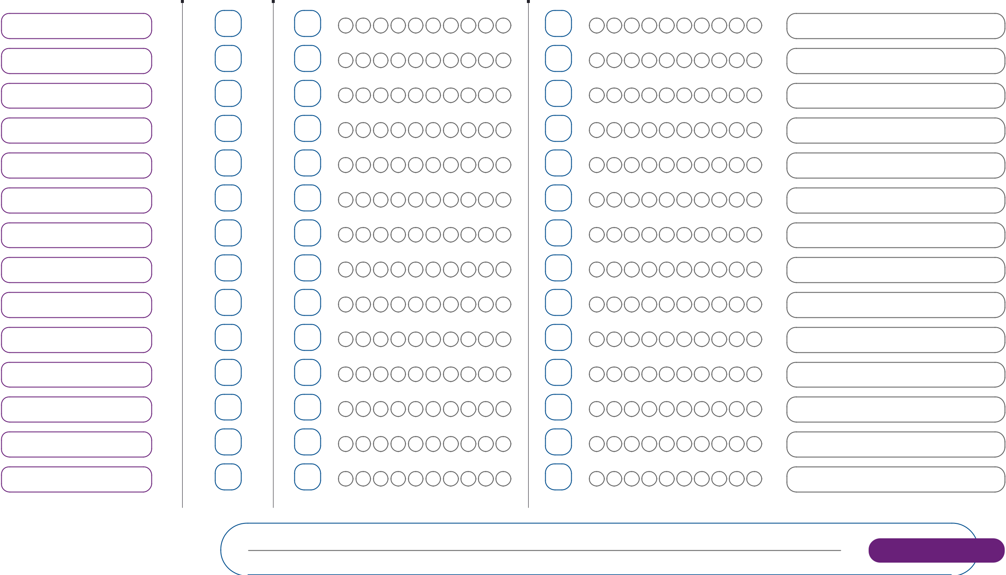

•
•

0544433443

