
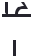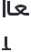 ﺳﺠﻞ أﻋﻤﺎل اﻟﺴﻨﺔ ﻟﻠﻨﻈﺎم اﻟﻔﺼﻠﻲ

اﻟﻤﺮﺣﻠﺔ اﻟﺜﺎﻧﻮﻳﺔ

 |  |  |  |  |  |  |  |  |  |  | • •
اﺳﻢ اﻟﻄﺎﻟﺒﺔ | 5 | 5 | 5 | 10 | 5 | 20 | 50 | 5 |  | 5 | 5 | 10 | 5 | 20 | 50
اﺳﻢ اﻟﻄﺎﻟﺒﺔ |  |  |  | • |  | • • | • • |  |  |  |  | • |  | • • | • •
 |  |  |  |  |  | •• | • • |  |  |  |  |  |  | •• | • •

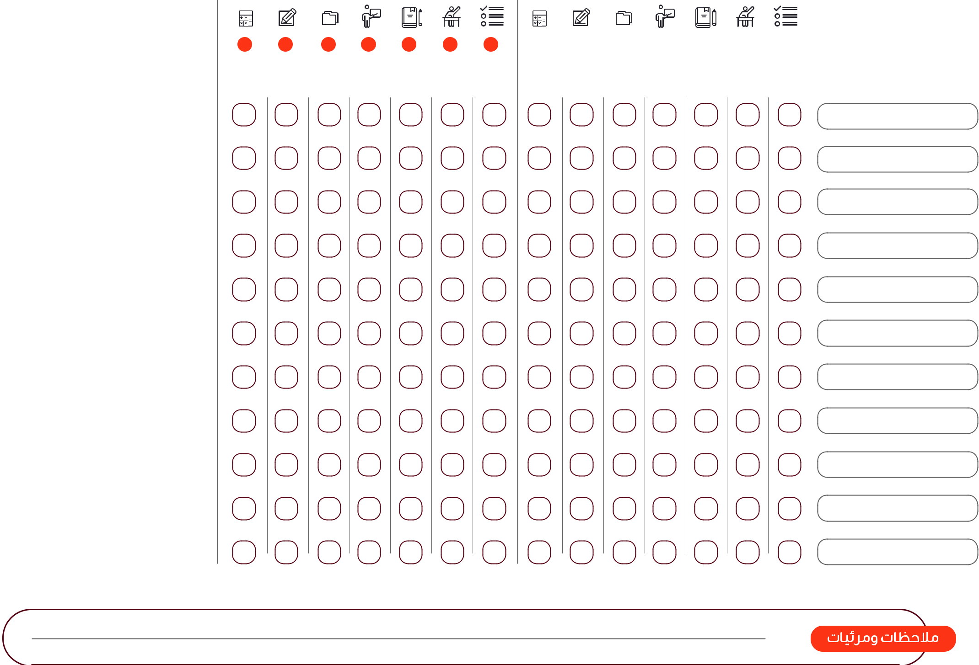

05 100 50




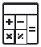



 ﺳﺠﻞ أﻋﻤﺎل اﻟﺴﻨﺔ ﻟﻠﻨﻈﺎم اﻟﻔﺼﻠﻲ

اﻟﻤﺮﺣﻠﺔ اﻟﺜﺎﻧﻮﻳﺔ

